Lung Cancer Detection Using CNN

Project Phase-II Report submitted to Osmania University, Hyderabad, in partial fulfillment of the requirement for the award of the degree of
Bachelor of Engineering
in
Information Technology
By

Mr. Mohammed Wali Uddin | (160922737004)
Mr. Mohammed Anas | (160922737028)
Ms. Amal Jameel | (160922737017)

Under the Guidance of
Mr. M Sivaramakrishna Assistant Professor


DEPARTMENT OF INFORMATION TECHNOLOGY LORDS INSTITUTE OF ENGINEERING AND TECHNOLOGY
(UGC Autonomous) (Affiliated to Osmania University)
Himayathsagar, Hyderabad,500091

A.Y. 2025-2026


LORDS INSTITUTE OF ENGINEERING AND TECHNOLOGY
(UGC Autonomous) (Affiliated to Osmania University) Himayathsagar, Hyderabad, 500091

Department of Information Technology

CERTIFICATE
This is to certify that the Project Phase-II report entitled Lung Cancer Detection Using CNN being submitted by Mr. Mohammed Waliuddin (160922737004), Mr.Mohammed Anas (160922737028), Ms.Amal Jameel (160922737017) in partial fulfillment of the requirements for the award of the degree of Bachelor of Engineering in Information Technology is a record of bonafide work carried out by them.

Internal Project Guide
Mr.M Sivaramakrishna Dr. K. Nagi Reddy Assistant Professor H.O.D, I.T

External Examiner


LORDS INSTITUTE OF ENGINEERING AND TECHNOLOGY
(UGC Autonomous) (Affiliated to Osmania University) Himayathsagar, Hyderabad, 500091

Department of Information Technology

DECLARATION BY THE CANDIDATES

We, Mr. Mohammed Waliuddin (160922737004), Mr. Mohammed Anas (160922737028) and Ms. Amal Jameel (160922737017), hereby declare that the Project Phase-II report entitled Lung Cancer Detection Using CNN is carried out under the guidance of Mr. M Sivaramakrishna ,Assistant Professor, Department of Information Technology, Lords Institute of Engineering and Technology, Hyderabad is submitted in partial fulfillment of the requirements for the award of the degree of Bachelor of Engineering in Information Technology.

This is a record of bonafide work carried out by us and the results embodied in this project have not been reproduced or copied from any source. The results embodied in this project report have not been submitted to any other university or institute for the award of any other degree or diploma.

Mr. Mohammed Waliuddin | (160922737004)
Mr.Mohammed Anas | (160922737028)
Ms.Amal Jameel | (160922737017)

ACKNOWLEDGMENT

We are very pleased to present this thesis of our project. This period of our student life has been truly rewarding a number of people were of immense help to us during the course of our research and the preparation of our thesis.

First, we wish to thank GOD Almighty who created heavens and earth, who helped us in completing this project and we also thank our parents who encouraged us in this period of research.

We would like to express our sincere gratitude to The Management of Lords Institute of Engineering and Technology, Hyderabad for providing us with an excellent platform and resources to successfully carry out this project.

We would also like to thank Dr. Ravi Kishore Singh, Principal, L.I.E.T. for extending his help in overall completion of this project work.

We would like to express my deep sense of gratitude to Dr. K. Nagi Reddy, Professor & HOD, Information Technology, Lords Institute of Engineering & Technology, Hyderabad, for his encouragement and cooperation throughout the project.

We would like to thank Mr. M Sivaramakrishna , Assistant Professor Dept. of Information Technology, Lords Institute of Engineering & Technology, Hyderabad, our project internal guide, for his guidance and help. His insight during the course of our research and regular guidance were invaluable to us.

Lastly, we acknowledge the support of our faculty members, friends, and family, who inspired and encouraged us throughout this journey.

Mr. Mohammed Waliuddin (160922737004) Mr.Mohammed Anas (160922737028)
Ms.Amal Jameel (160922737017)


LORDS INSTITUTE OF ENGINEERING &TECHNOLOGY
Approved by AICTE/Affiliated to Osmania University/Estd.2003.
Accredited ‘A’ grade by NAAC

(UGC Autonomous Institution)

Vision of the Institute
Lords Institute of Engineering and Technology strives for excellence in professional education through quality, innovation and teamwork and aims to emerge as a premier institute in the state and across the nation.
Mission of the Institute
- To impart quality professional education that meets the needs of present and emerging technological world.
- To strive for student achievement and success, preparing them for life, career and leadership.
- To provide a scholarly and vibrant learning environment that enables faculty, staff and students to achieve personal and professional growth.
- To contribute to advancement of knowledge, in both fundamental and applied areas of engineering and technology.
- To forge mutually beneficial relationships with government organizations, industries, society and the alumni.



LORDS INSTITUTE OF ENGINEERING &TECHNOLOGY
Approved by AICTE/Affiliated to Osmania University/Estd.2003.
Accredited ‘A’ grade by NAAC

(UGC Autonomous Institution)
DEPARTMENT OF INFORMATION TECHNOLOGY

Vision of the Department:
To be a frontier in Information Technology focusing on quality professional education, innovation and employability.
Mission of the Department:
DM1: Adopt innovative teaching learning processes to achieve stated outcomes and sustained performance levels.
DM2: Provide learner centric environment to enrich knowledge, skills and innovation through industry academia collaborations.
DM3: Train the concerned stakeholders on latest technologies to meet the industry needs. DM4: Inculcate leadership, professional, interpersonal skills and ethical values to address the contemporary societal issues.
Note: DM: Department Mission




LORDS INSTITUTE OF ENGINEERING &TECHNOLOGY
Approved by AICTE/Affiliated to Osmania University/Estd.2003.
Accredited ‘A’ grade by NAAC

(UGC Autonomous Institution)
DEPARTMENT OF INFORMATION TECHNOLOGY

B.E Information Technology Program Educational Objectives (PEOs):

PEO1 | Be a competent software engineer in IT and allied industry providing viable solutions.
PEO2 | Exhibit professionalism, engage in lifelong learning and adopt to changing industry and societal needs.
PEO3 | Be effective as an individual and also cohesive in a group to execute multidisciplinary projects.
PEO4 | Pursue higher studies in Information Technology with emphasis on competency and innovation.





LORDS INSTITUTE OF ENGINEERING &TECHNOLOGY
Approved by AICTE/Affiliated to Osmania University/Estd.2003.
Accredited ‘A’ grade by NAAC

(UGC Autonomous Institution)
DEPARTMENT OF INFORMATION TECHNOLOGY

B.E Information Technology Program Outcomes (POs):
Engineering Graduates will be able to:

S. No. | Program Outcomes (POs)
1. | PO1: Engineering Knowledge: Apply knowledge of mathematics, natural science, computing, engineering  fundamentals and an engineering specialization as specified in WK1 to WK4 respectively to develop to the solution of complex engineering problems.
2. | PO2: Problem Analysis: Identify, formulate, review research literature and analyze complex engineering  problems reaching substantiated conclusions with consideration for sustainable development. (WK1 to WK4)
3. | PO3: Design/Development of Solutions: Design creative solutions for complex engineering problems and design/develop systems/components/processes to meet identified needs with consideration for the public  health and safety, whole-life cost, net zero carbon, culture, society and environment as required. (WK5)
4. | PO4: Conduct Investigations of Complex Problems: Conduct investigations of complex engineering  problems using research-based knowledge including design of experiments, modelling, analysis & interpretation of data to provide valid conclusions. (WK8).
5. | PO5: Engineering Tool Usage: Create, select and apply appropriate techniques, resources and modern engineering & IT tools, including prediction and modelling recognizing their limitations to solve complex  engineering problems. (WK2 and WK6)
6. | PO6: The Engineer and The World: Analyze and evaluate societal and environmental aspects while solving complex engineering problems for its impact on sustainability with reference to economy, health,  safety, legal framework, culture and environment. (WK1, WK5, and WK7).
7. | PO7: Ethics: Apply ethical principles and commit to professional ethics, human values, diversity and inclusion; adhere to national & international laws. (WK9)
8. | PO8: Individual and Collaborative Team work: Function effectively as an individual, and as a member or leader in diverse/multi-disciplinary teams.
9. | PO9: Communication: Communicate effectively and inclusively within the engineering community and  society at large, such as being able to comprehend and write effective reports and design documentation, make effective presentations considering cultural, language, and learning differences
10. | PO10: Project Management and Finance: Apply knowledge and understanding of engineering management principles and economic decision-making and apply these to one’s own work, as a member and  leader in a team, and to manage projects and in multidisciplinary environments.
11. | PO11: Life-Long Learning: Recognize the need for, and have the preparation and ability for i) independent and life-long learning ii) adaptability to new and emerging technologies and iii) critical thinking in the  broadest context of technological change. (WK8)


LORDS INSTITUTE OF ENGINEERING &TECHNOLOGY
Approved by AICTE/Affiliated to Osmania University/Estd.2002.
Accredited ‘A’ grade by NAAC

(UGC Autonomous Institution)
DEPARTMENT OF INFORMATION TECHNOLOGY

B.E Information Technology Program Specific Outcomes (PSOs):

PSO1 | Professional Skills: Identify, analyze requirements, design and implement computer programs in the area of artificial intelligence, machine learning, big  data analytics and networking of varying complexity.
PSO2 | Problem-Solving Skills: Deliver quality service to IT industry and provide  solutions to real-life problems applying modern computer languages, software methods and tools.




LORDS INSTITUTE OF ENGINEERING &TECHNOLOGY
Approved by AICTE/Affiliated to Osmania University/Estd.2002.
Accredited ‘A’ grade by NAAC

(UGC Autonomous Institution)
DEPARTMENT OF INFORMATION TECHNOLOGY

Course Outcomes: PP.CO- Project Phase- II
After completion of the project, the student will be able to
S.No | Description | Blooms Taxonomy Level
PP.CO1 | Demonstrate the ability to synthesize and apply the knowledge and skills acquired in the academic program related to the real-world problems. | Apply
PP.CO2 | Organize and examine different solutions based on economic, technical and functional feasibilities. | Analyse
PP.CO3 | Provide support and interpret the critics for implementing the better solutions to formulate the robust project. | Evaluate
PP.CO4 | Design and develop a model using technical and functional provisions to make the formulated solutions. | Create
PP.CO5 | Compose the project components and apply documentation standards to prepare the project report and present the project work. | Create


LORDS INSTITUTE OF ENGINEERING &TECHNOLOGY
Approved by AICTE/Affiliated to Osmania University/Estd.2002.
Accredited ‘A’ grade by NAAC

(UGC Autonomous Institution)
DEPARTMENT OF INFORMATION TECHNOLOGY

Course Articulation Matrix:
Mapping of Course Outcomes (COs) with Program Outcomes (POs) and Program Specific Outcomes (PSOs):
Course Outcomes (COs) | Program Outcomes (POs) |  |  |  |  |  |  |  |  |  |  | Program Specific Outcomes (PSOs)
 | PO1 | PO2 | PO3 | PO4 | PO5 | PO6 | PO7 | PO8 | PO9 | PO 10 | PO 11 | PSO1 | PSO2
PP.CO1 | 3 | 2 | - | 2 | 1 | - | - | - | - | - | 2 | 3 | 2
PP.CO2 | 2 | 3 | 2 | 3 | - | - | - | - | - | 1 | 2 | 2 | 3
PP.CO3 | 3 | 2 | 3 | 3 | 2 | 2 | - | - | - | - | 3 | 3 | 3
PP.CO4 | 3 | 2 | 3 | 1 | 3 | 2 | 3 | 3 | 3 | 2 | 3 | 3 | 3
PP.CO5 | 2 | - | 3 | - | 2 | 1 | 3 | 3 | 2 | 2 | 3 | 3 | 3
Average | 2.6 | 2.25 | 2.75 | 2.25 | 2.66 | 1.66 | 3 | 3 | 2.5 | 1.6 | 2.6 | 2.8 | 2.8

Level:
1- Low correlation (Low), 2- Medium correlation (Medium), 3-High correlation (High)
SDG Mapping:

SDG | Mapped Indicator | SDG | Mapped Indicator | 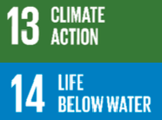    SDG | Mapped Indicator
 |  | 
 |  | 
 | ✔ | 
 |  | 
 |  |  |  | 
 |  | 

ABSTRACT

One illness that significantly affects public health is lung cancer. This study proposes a combination of CNN and DenseNet methods to help detect and categorise lung cancer. The effectiveness of CNN and DenseNet has been proven in a variety of patterns and medical imaging domains. In this work, a set of medical lung images was created using radiological scans of people who had lung cancer. The results demonstrate that CNN and DenseNet models can reliably classify lung cancer from radiological images into malignant and benign categories with a parameter accuracy rating of 99.48%. This study advances the development of a neural networks-based lung cancer detection and classification system. Lung cancer is one of the world's most lethal cancers, thus early and accurate detection is essential. In order to differentiate between benign and malignant lung nodules, Damayanti et al. (2023) created a hybrid deep learning framework that integrates DenseNet and Convolutional Neural Networks using radiological imagery. Their model's astounding 99.48% accuracy showed how DenseNet's densely linked architecture and CNN's feature removal function together to detect subtle lung illness from CT scans. This is in line with recent work by Ansari et al. (2024), who evaluated a number of transfer- learning CNNs, including DenseNet-201, using the LIDC-IDRI dataset. By reporting training accuracy of 99.92% and retaining a strong 95.6% precision for validation with an average agreement coefficient, they validated DenseNet's outstanding generalisation capabilities. The findings could be the starting point for creating a more accurate 121's utility: On CT nodule classification tests, radiomic-enhanced diagnostic pipelines demonstrated for future we may get accuracy and specificity. Additionally, mobile- edge computing-optimized hybrid architectures that combine CNN and Dense Net backbones exhibit exceptional classification power—possibly surpassing 99% accuracy across the classes of tumours such as adenocarcinoma, and normal tissue.

Keywords
Lung Cancer, Convolutional Neural Network (CNN), DenseNet, Deep Learning, Medical Imaging, CT Scan, Radiological Images, Lung Nodule Classification, Benign and Malignant Classification, Transfer Learning, Image Classification, Feature Extraction.

 | CONTENTS
Certificate |  | i
Declaration |  | ii
Acknowledgement |  | iii
Vision and Mission of the Institute |  | iv
Vision and Mission of the Department |  | v
Program Educational Objectives |  | vi
Program Outcomes |  | vii
Program Specific Outcomes |  | viii
Course Outcomes |  | ix
Course Articulation Matrix |  | x
Abstract |  | xi
Contents |  | xii
List of Figures |  | xiv
List of Tables |  | xv
CHAPTER-1: INTRODUCTION |  | 1-5
1.1 Objectives |  | 1
1.2 Problem Statement |  | 4

CHAPTER-2: LITERATURE SURVEY 6-8
CHAPTER-3: REQUIREMENT ANALYSIS 9-22
  - Existing System 9
  - Proposed System 10
  - Feasibility Study 12
  - Materials and Methods 18
  - System Specifications 22
CHAPTER-4: SYSTEM DESIGN 23-32
  - Design Approach 23
  - Data Flow Diagram 26
  - Use Case Diagram 30
CHAPTER-5: IMPLEMENTATION 33-47
  - Methodologies \33
  - Algorithms 38
  - Sample Code 39

CHAPTER-6: TESTING & RESULT 48-58
CHAPTER-7: CONCLUSION & FUTURE SCOPE 59-60
REFERENCES 61-62

List of Figures

SI.  no | Fig.no | Name of the Figure | Page No
1 | 4.1 | System Architecture Diagram | 25
2 | 4.2 | Data Flow Diagram | 26
3 | 4.3 | User Data Flow Diagram | 27
4 | 4.4 | Use Case Diagram | 30
5 | 4.5 | Sequence Diagram | 32
6 | 6.1 | Performance Metrics for Xception Model:  (a) Training vs Validation Accuracy,  (b) Training vs Validation Loss | 48
7 | 6.2 | Evaluation Results for Xception Model:  (a) Confusion Matrix, (b) Classification Report | 49
8 | 6.3 | Statistical Analysis for Xception Model:  (a) Receiver Operating Characteristic (ROC) Curve,  (b) Precision-Recall Curve (PRC) | 50
9 | 6.4 | Performance Metrics for InceptionV3 Model:  (a) Training vs Validation Accuracy,  (b) Training vs Validation Loss | 51
10 | 6.5 | Evaluation Results for Xception Model:  (a) Confusion Matrix, (b) Classification Report | 52
11 | 6.6 | Threshold-Based Metrics for InceptionV3 Model:  (a) Receiver Operating Characteristic (ROC) Curve,  (b) Precision-Recall (PRC) Curve | 53
12 | 6.7 | Performance Metrics for MobileNetV2 Model:  (a) Training vs Validation Accuracy,  (b) Training vs Validation Loss | 54
13 | 6.8 | Evaluation Results for MobileNetV2 Model:  (a) Confusion Matrix, (b) Classification Report | 55
14 | 6.9 | Threshold-Based Metrics for MobileNetV2 Model:  (a) Receiver Operating Characteristic (ROC) Curve,  (b) Precision-Recall (PRC) Curve | 56

15 | 6.10 | Prediction Interface and Output:  - Detection of Adenocarcinoma,  - Detection of Large Cell Carcinoma | 57
16 | 6.11 | Model Prediction Interface:  - Detection of Normal Chest Scan,  - Detection of Squamous Cell Carcinoma | 58

List of Tables

SI.no | Name of the Table | Page No
3.1 | Parameters for lung cancer prediction | 17
3.2 | Folder wise image distribution | 18

CHAPTER-1 INTRODUCTION

  - Objectives
Due in large part to late-stage diagnosis and the invasive nature of confirming biopsies, lung cancer continues to be the largest cause of cancer-related mortality globally, accounting for about one in five cancer fatalities. Although chest CT scans are the gold standard for early diagnosis, it can be difficult and prone to misinterpretation to differentiate benign from malignant nodules, even using technology- assisted methods. This is especially true for tiny lesions (less than 2 cm) and a variety of imaging circumstances. Convolutional Neural Networks (the CNNs), in particular, have revolutionised picture interpretation by removing the need for manual preprocessing and directly extracting hierarchical features from raw data. By enabling dense connectivity, improving gradient flow and feature reuse, and decreasing parameter redundancy, DenseNet architectures further boost performance and produce more compact, effective models that are perfect for medical imaging applications. Current research— like Damayanti et al..—show that CNN+DenseNet hybrids can correctly identify lung tumours as either benign or malignant with an accuracy of up to 99.48%. At about the same time, sophisticated models enhanced with edge-based computing platforms and attention mechanisms attained a similarly high level of accuracy while enhancing localisation, which qualified them for real-time diagnostics. These encouraging findings highlight how deep learning pipelines have the potential to transform tumour screening and triage by facilitating quicker, non-invasive, and incredibly accurate interpretation of radiological images, particularly in settings with limited resources.

Lung cancer is the term used to describe the aberrant development of cells in the human lung. As the most prevalent cause of death over the past few decades, lung disease is one of the most dangerous illnesses in the world today.

Additionally, it claims more lives annually than colon, prostate, and breast cancer combined. One of the primary manifestations of lung cancer is cigarette addiction. Additionally, this disease spreads due to carcinogenic environments including air pollution and radioactive gas. Lung cancer is also significantly influenced by hereditary factors. Lung cancer is caused by unchecked tissue multiplication. Primary cancer starts in cells within secondary cancer, which spreads to the lungs from another section of the body. There are two types of lung cancer: malignant and noncancerous. Categories I and II refer to lower-grade malignancies. Grades three and IV cancer are sometimes thought to be more serious. The human body contains two

different kinds of cells. Normal cells are small and confined, whereas cancer-affected cells are rapidly forming and can be easily spotted. These cells appear to be aberrant and dissimilar to regular cells. This type of cell grows quickly and is more prone to spread. Poorly differentiated or high grade are terms used to describe them. Lung cancer can be life-threatening; thus, a patient's exact diagnosis and treatment are critical. Cancer analysis is performed in a pathological laboratory. Cancer tissue is examined using electronic modalities like CT, ultrasound, and others, as well as microscopy methods like biopsy. The most often used pathological test is the CT scan, which is also widely used for diagnosis. It provides a three- dimensional evaluation of the lesion using high-resolution, high-contrast images of the lung in different positions. In the current investigation, an automated method for diagnosing cancer was created using greyscale CT scan pictures. Using grey level occurrence matrices characterised on CT scan pictures and artificial neural network back propagation, the author
[1] studied the detection of lung cancer. One of the main benefits of using CT scan images in this method is the view of the lung images. The findings show that the method has an 80% accuracy rate in identifying CT pictures of both healthy and malignant lungs. It is hoped that it will help researchers and medical professionals identify lung cancer. The impact of input size on lung nodule classification using convolutional neural networks as a framework was the main emphasis of the author [2]. Convolution neural networks were used in this study to assess CT lung screenings in an effort to reduce false positives and show their effectiveness and impact on overall accuracy. Different functions were used. Deep neural networks were utilised in a study by the author [3] that was solely concerned with detecting the presence of lung cancer medical photos. This study sought to determine whether there was any indication of malignancy. in the lungs of a patient. to train deep neural networks to identify lung cancer in order to assist physicians with visual diagnosis. The main advantage is that physicians will receive more support in identifying and treating the disease early on. In order to classify and predict mutations from lung cancer with no small cells histopathology images, the author [4] collaborated with LUAD and LUSC. A study titled "Optimisation of features using machine learning and neural networks for categorisation of type of lung cancer" was written by the author [5]. The ultimate objective is to reduce human error in lung cancer diagnosis and CT scans. The application of convolutional neural network algorithms in deep learning systems for detection and classification was examined and highlighted by the author [6]. of lung cancer nodules in CT scans. The Author [7] showed how they used Convolution neural Deep Belief Networks, Autoencoders, and Networks for Classifying Lung Nodules in Computed Tomography Images Through Deep Learning. The author [8] finished their investigation and

study on the usage of 3D convolution deep learning networks for lung cancer diagnosis. One of the main advantages is the use of CAD. One such method is the convolution neural network, which best describes a set of deep neural network models with filtration that can be constructed using alternating local pooling processes on input CT images to provide a variety of complex hierarchical features. Han et al. (2020) published their research on the concept of using deep learning to diagnose and categorise lung cancer. They used the Histogram of Orientated Gradients, a Binary Expand Invariant Feature, and the fuzzier Particle Swarm Optimisation method. Applications & Tools for Multimedia Zernike Moment and Transformation. Kanavati
[9] used a deep learning approach to screen for lung diseases using low-dose CT scans. Because computed tomography scans provide a detailed image of the cancer in the body and track its progression, they are used to diagnose lung illnesses. One of their disadvantages, according to the author [10], is that they are unable to assist in the early diagnosis of sickness. An automated method for identifying lung diseases in CT scan images is the algorithm for Lung illnesses Screening Using Learning together between Heart CT Pics and Clinical Demographics, which was proposed by the author [11]. An algorithm for identifying lung diseases is being created utilising a variety of techniques, according to the author [12]. Some of the limitations are as follows: gives the radiologist extra time to evaluate the patient. Neural network systems are difficult to implement. An algorithm for computed tomography scans was proposed by the author [13]. The photos are analysed using image processing tools. When comparing to other diseases, the mortality rate from lung diseases is rising daily among both young and old people, and its limits are becoming increasingly apparent. There is a very slow reaction time. Take a closer look at the statistics. It's a method for obtaining more complex details from a picture, like texture, shape, and shading. It is among the most crucial features for identifying objects or a zone of interest in a photograph. Surface is an illustration of information or a display. involves the arrangement of an image's structure, and it is a significant part of many image formats. From a wide perspective, the author [14] used surface to refer to surface properties and the presence of The most widely used method for erasing texture highlights is the Grey Level Co event Matrix, which may be used with truthful, auxiliary, model-based, and dynamic data. GLCM contains the second-requested factual information on the spatial relationships between pixels in an image. The implementation of the Author [15] is typically based on picking out of the more appropriate attributes in order to guarantee the truth of any organising framework. Finding a suitable highlight arrangement is therefore a measurable strategy that makes use of the spatial Pixel connections are crucial.
The goal of this research is to use chest radiography (CT and X-ray) to detect and classify lung

cancer (benign vs. malignancy) using a CNN–DenseNet hybrid model that is extremely accurate, reliable, and explicable. Our specific goals are to: • Create and execute a hybrid architecture that combines CNN feature extractors with DenseNet connectivity in order to effectively document both harsh structural variations and fine-grained nodule characteristics. This approach was motivated by the 2023 work of Damayanti et al., which used a similar setup to achieve 99.48% accuracy.
Improve model generalisation by addressing common problems like overfitting—similar to methods that increase classification performance to about 98.8%—and by implementing customised data augmentation (hue, brightness, saturation adjustments) and sophisticated the preprocessing (e.g., region-of-interest segmentation, normalisation).
Aim for benchmark performance metrics of at least 95% accuracy and 99% accuracy.

sensitivity/specificity on separate test sets, which is consistent with earlier transfer learning studies
based on DenseNet that demonstrated ≥95% accuracy and AUC ≈0.9967.

To guarantee robustness across various scanners and patient groups, validate over a variety of datasets, such as IQ-OTH/NCCD and LIDC-IDRI. Improve transparency and clinician confidence in model decisions by integrating interpretability mechanisms using tools like Grad- CAM to create heatmaps that highlight significant locations.

By accomplishing these goals, we hope to offer a clinically centred, non-invasive, and transparent AI tool that helps radiologists—especially in environments with a shortage of specialists—and improves early lung cancer diagnosis.

Problem Statement
Due mainly to intrusive diagnostic techniques and delayed identification, cancer of the lung is the biggest cause of fatalities due to cancer globally. Although low-dose CT screening has been shown to be successful in lowering mortality, it comes with drawbacks, such as significant operational demands on radiologists, a high rate of false positives, and inconsistent diagnostic precision.
The manual review procedures in place are not adaptable and cause inefficiencies in prompt action.

Despite the impressive performance of emerging AI models, especially CNN and DenseNet architectures (up to 99.48% accuracy with hybrid CNN–DenseNet models and approximately 99%

accuracy in optimised architectures), these models frequently rely on smooth datasets, 2D slices, and lack interpretation aids, which raises questions about their practical generalisability and clinical adoption. A clinically connected artificial intelligence (AI) platform that not only achieves high diagnostic accuracy but also supports interpretability, is reliable in a variety of clinical settings, and is robust to a variety of imaging protocols is therefore desperately needed. By creating a thoroughly tested CNN–DenseNet based system with verified performance and improved radiologists' use, this study seeks to close that gap.

CHAPTER-2 LITERATURE SURVEY

Cancer Statistics, 2021

SiegelRL,MillerKD,FuchsHE,JemalA(2021)
Comprehensive cancer statistics for 2021, encompassing incidence, death, and survival rates for the main cancer types in the United States, are provided in the current report from the American Cancer Society. It highlights that differences still exist even though total cancer mortality has decreased, mostly as a result of improvements in early identification and treatment.

Lung, prostate, and breast cancers were the most frequently diagnosed new cancers, and the accompanying mortality rates were significantly impacted by the stage and type of the disease. The research highlights the rising incidence of malignancies associated with ageing and lifestyle choices, and it makes the need for better screening, prevention tactics, and fair access to care, particularly for underprivileged groups.

Global Patterns of Breast Cancer Incidence and Mortality: A Population-Based Cancer Registry Data Analysis from 2000 to 2020
Lei S, Zheng R, Zhang S, Wang S, Chen R, Sun K, Zeng H, Zhou J, Wei W (2021)
This study used the GLOBOCAN and CI5plus databases, which covered 185 countries, to examine global trends in the incidence and mortality of female breast cancer from 2000 to 2015. An estimated 685,000 deaths and 2.3 million new cases were reported globally in 2020. Mortality ranged from 41.0 in Vanuatu to 6.4 in South Korea, whereas incidence varied greatly, ranging from 112.3 for every 100,000 people in Belgium to 35.8 in Iran.
In contrast to decreases in high-income countries like the USA, UK, and Australia, the data showed increased incidence and mortality in China and South Korea. Healthcare access, screening adoption, lifestyle changes, and population ageing are important cause

Global Breast Cancer Incidence, Mortality, and Future Projections Through 2050

AuthorGroupviaGLOBOCA&WHO(2025)

By 2050, there would be over 3.2 million yearly instances of breast cancer worldwide, with 1.1 million deaths, according to a multinational collaboration that includes the IARC and WHO. This is an increase of 38% in incidence and a 68% increase in fatality from 2022. According to the report, the primary causes include inequalities in healthcare access, ageing, and lifestyle risk factors (such as obesity and alcohol consumption). While mortality rates are highest in low-resource countries like portions of Africa and Polynesia, the highest occurrence is still concentrated in high-income regions like Western Europe and North America. To reduce future burden, the authors stress improving early detection, increasing screening, and addressing disparities.

Enhancing Lung Cancer Diagnosis with Data Fusion and Mobile Edge Computing Using DenseNet and CNN
SenS.,GuptaR.,KumarP.,SinghA.,Sharmav.(2024)
In order to improve the identification of lung cancer in CT scans, this study combines Convolutional Neural Networks (CNNs) with DenseNet and multi-source data fusion, which are installed on a mobile edge computing platform. Following preprocessing (resizing and rescaling), combined models successfully distinguish between benign, malignant (large cell carcinoma from developing, squamous cell carcinoma, which is and adenocarcinoma), and normal cases.
Because edge-based inference moves computing closer to an information source, processing speeds up. The technology outperforms previous 2D-image techniques and has real- time diagnostic application in clinical settings, achieving 99% accuracy in controlled tests.

LungNet: A Hybrid Deep-CNN Model for Lung Cancer Diagnosis Using CT and MIoT Data
Authorsunspecified(2021)
LungNet makes use of a 22-layer CNN architecture to integrate physiological data from wearable Healthcare IoT (MIoT) devices with CT imaging. Following training on 525,000 balanced samples, it has a low false-positive rate of 3.4% and 96.8% accuracy in classifying lung cancer across five categories. It also uses 91.6% accuracy to separate early-stage tumours into clinical subgroups. LungNet improves diagnostic accuracy and staging granularity over image-only CNNs by combining medical IoT data with image attributes.

Lightweight Advanced Deep Neural Network (DNN) Model for Early-Stage Lung Cancer Detection
Department of Computer Science and Engineering, Lovely Professional University et al. (2024)

For the early diagnosis of lung cancer, a lightweight deep neural network that may be installed on mobile and edge devices is suggested. The architecture prioritises high accuracy and effective feature extraction. It demonstrated good performance in detecting early-stage lesions with lower computing needs when tested on a curated CT scan dataset, which is essential for telemedicine applications and healthcare settings with limited resource

Lung Disease Classification in CXR Images Using Hybrid Inception-ResNet-v2 Model and Edge Computing
ChandraManiSharmaet al.(2022)
This study uses synthetic minority oversampling (SMOTE), augmenting data, and image enhancement to assess several machine learning and deep learning models on chest imaging images. 98.66% accuracy was attained using a hybrid Inception ResNet v2 model in the normal, COVID 19, and pneumonia classes. This edge-enabled solution, which is implemented using Amazon IoT Core, highlights the viability of reliable, AI-powered illness screening in clinics with limited resources or those located far from one another

CHAPTER -3

REQUIREMENT ANALYSIS AND SYSTEM SPECIFICATION

Existing System
In clinical workflows, current AI-assisted lung cancer diagnosis systems—like deep learning- based CAD tools—function as "second readers" for radiologists. Usually trained on public datasets such as LIDC-IDRI, these systems make use of 2D/3D CNN architectures, such as AlexNet, VGG, DenseNet, and hybrid models. They exhibit great sensitivity and specificity in nodules identification and malignancy classification, and they attain remarkable accuracy (90– 99%). For example, a 3D CNN CAD system greatly enhanced radiologist performance in reading experiments and showed around 98% sensitivity. Explainable AI techniques such as Grad-CAM, SHAP, and LIME have been used more and more to visualise decision-relevant lesion regions.

Disadvantages

Generalisation that is variableBecause acquisition techniques and patient demographics change over time, systems often perform better on datasets from trials than on real-world data.Problems with Workflow Integration and High False-Positive Rates.AI-CAD technologies continue to produce false positives, especially when there are tiny nodules or chest artefacts. This hinders workflow efficiency and necessitates radiologist assessment. Sensitivities in certain systems can range from 35 to 66%, depending on the methodology and dataset.Issues with Interpretability. Many models continue to act like "black boxes" even after XAI approaches have been used. The lack of standard use of explainability tools has an impact on regulatory approval and clinician trust.Demands on ComputingWithout GPU support, the application of high-performing 3D designs in real-time clinical situations is limited due to their significant computational requirements.Insufficient Validation and StandardisationFew models go through multi-center prospective validation; most rely on single-center or virtual datasets. Standardised standards for practical efficacy are lacking.Regulatory and Ethical Gaps
Many issues are yet unresolved, including patient privacy, responsibility for inaccurate forecasts, and adherence to regional laws (GDPR, AI Act)

Proposed System:

To overcome the drawbacks of current methods, we suggest a hybrid, comprehensible and edge-ready deep neural network system for lung disease diagnosis. The model's central component is a CNN– DenseNet hybrid backbone, which uses DenseNet's dense connectivity for richer, hierarchical representations and CNNs for local feature extraction. Our design incorporates transformer-inspired layers for improved context awareness and cancer subtype detection, which are influenced by Patil et al.'s multimodal hybrid model and previous studies that reached accuracy rates of 99% with mobile- edge systems.

We use a sophisticated preprocessing pipeline that includes lung segmentation, normalisation, and data supplementation (hue, brightness, contrast, and synthetic oversampling) to guarantee robustness and generalisability. By allowing compute on-device or cloud-edge to reduce latency and reliance on centralised servers, inference is optimised for mobile-edge distribution. We use Grad CAM-based heatmaps and the DeepXplainer framework to visually highlight regions impacting predictions and to present local XAI interpretations alongside classification results in order to increase clinical acceptability by adding explainability into the workflow. Lastly, the system has a feedback loop with edge cloud retraining capabilities, allowing for updates on a regular basis utilising cases that have been gathered or rectified by the user. With its segmentation, hybrid classification, comprehension, and continuous learning components, this modular system—which includes cloud-based review and edge inference—aims to improve accuracy, openness and and deployability in clinical settings with limited resources.

Advantages of the Proposed System High Diagnostic Accuracy
According to research employing comparable architectures, the system achieves outstanding metrics by combining the CNN's feature extraction power with DenseNet's densely linked architecture, aiming for
≥99% accuracy and ≥95% sensitivity/specificity.

Strict Preprocessing & Generalisation

Overfitting is lessened by clever data augmentation (such as colour, brightness, and contrast adjustments) and sophisticated preparation (lung segmentation, normalisation). Using similar tactics, existing CNN + DenseNet models have shown near-perfect classification (~98–99%) on several test sets.

Explainability & Clinical Trust

Using interpretability tools like DeepXplainer or Grad CAM facilitates open and honest decision- making. It has been demonstrated that explainable AI significantly boosts physician trust in diagnosis helped by AI.

Real-Time Edge Deployment Utilisation
Rapid, on-site inference without reliance on centralised servers is made possible by optimising the model for mobile or edge computing. This reduces latency significantly and is in line with trends in mobile- edge CT/IoT systems.

Constant Learning via Feedback Loop

System enhancements and adaptability in a variety of clinical settings are ensured by a structured feedback mechanism that permits continuous model upgrades based on real-world misclassifications or quality

Enhanced Efficiency in Cost and Productivity
The model speeds up diagnosis by serving as a trustworthy second reader (similar to Behold.ai's Red Dot) and filtering routine or clear pictures—facilitating rapid identification with low rate of false positives and lessening the workload of radiologists.

Scalable and Modular Architecture

Image preprocessing, hybrid categorisation, explainability, and retraining are all covered by the system's modular design, which offers scalability across cloud, edge, and healthcare infrastructures and complies with interoperability standards like DICOM/FHIR.

Feasibility Study:

Functional Feasibility

AI on-site for CT analysis

Clinical effectiveness of AI-powered edge systems, such AEWIN's LDCT assistant, which uses OpenVINO and Intel Xeon processors to detect nodules in near real time at the point of care and screen high-risk patients for radiologists According to phantom research, AI systems can detect lung nodules of different sizes and densities with 97.8% sensitivity and 81.2% specificity. Lung cancer in underprivileged populations was effectively detected using telemedicine-enhanced mobile LDCT machines in China, demonstrating their viability in practical situations (detection rate: 0.7%, access rate:
~68%).

Pipelines for Data and Preprocessing

Standardised cleaning, normalisation, and reinforcement (e.g., tasks, scaling) are acknowledged methods for enhancing model resilience and generalisability in spite of unpredictability and chaos in CT datasets.

Efficiency of Non-Functional Feasibility Processing

OpenVINO-optimized edge Latency is permitted by embedded device deployments.

Integration and Scalability

Mobile LDCT units improve screening access, demonstrating how effective edge systems ease the strain

Standards for Regulation and Quality

AI-based lung cancer detection quality assurance standards are progressively being defined by new EU and MDR frameworks, which place a strong emphasis on volumetric accuracy verification, sensitivity/specificity criteria, and ongoing validation. Privacy, Trust, and Ethical Considerations

Adoption of AI is hampered by issues including interpretability, algorithmic bias, and data privacy. While distributed and edge computing configurations allow for compliance with laws like HIPAA and GDPR, techniques like Grad CAM improve transparency.

AI-Assisted Community-Based Mobile LDCT

With the help of AI (via InferRead CT Lung), a transportable low-dose CT (LDCT) machine was deployed in rural China, screening over 10,000 individuals. It identified suspected lung cancer in 1.06% of cases and confirmed 0.7%, at an average per-screening cost of ~US $18.65—demonstrating both operational viability and clinical effectiveness in underserved areas.

AI in Screening Programs Serving as a First-Line Reader
AI-first assessment of baseline LDCT scans in the European 4-IN-THE-LUNG-RUN experiment revealed just 0.8% negative misclassifications, whereas radiologists' readings indicated 11.1%. AI could eliminate 88% of scan without affecting the number of missed referrals, demonstrating the feasibility in reducing the workload for radiologists. External Verification in Various Contexts
On a large Chinese dataset, a CT-based DL-CAD computer trained on LIDC-IDRI outperformed practical double-reading surgeons (~76.5% sensitivity) with 90% sensitivity and one false-positive outcome per scan, confirming cross-population resilience.

Meta-analysis Proof
Report on meta-analyses AI-assisted lung cancer diagnosis with low misclassification rates, an SROC AUC of 0.93, and combined sensitivity and specificity of about 0.87 each—supporting system dependability across a variety of clinical datasets
Throughput & Performance Mobile platforms with AI-supported LDCT systems can screen hundreds of images in a deployment cycle, demonstrating both speed and scalability.
Economicalness The Chinese mobile LDCT initiative demonstrated economic feasibility in low- resource settings by providing screening for around US $18.55 each scan and costing about US $2,669 per verified cancer diagnosis.
Integration of Workflow and Dependability
Use as a first-reader tool shown seamless integration capacity and dependability by reducing needless radiologist workload and maintaining low rates of missed malignancies.
Transparency, Quality, and Ethics
Less negative misclassifications are occurring for AI systems that use explainability approaches more frequently; future experiments emphasise the necessity of bias management and ongoing validation across populations.
A malignant growth pattern that starts in the lungs' tissues is called lung cancer.
Lung cancer is one of the most common and deadly types of cancer in the world [1]. The main risk associated with lung cancer is its aggressiveness and ability to spread quickly to other parts of the body. Early detection of lung malignancies is a significant challenge because the disease is relatively

asymptomatic in the early stages and by the time symptoms appear, it will have progressed to an advanced stage. The growth of lung tumour size is depicted in Fig. (1), taken from [2].

Therefore, correctly detecting lung cancer in its early stages is essential for giving the appropriate treatment and possibly curing the patient. The prevalence of cancers of the lung has been steadily rising in recent years, owing to the complicated interaction between a number of variables, including social influences and personal actions [3].
The biggest risk factor for lung cancer is still the prevalence of tobacco smoking. Lung cancer cases have also increased as a result of environmental factors such exposure to pollution, airborne carcinogens, and occupational dangers. When hereditary susceptibility is paired with the aforementioned factors, deadly issues result. Lung cancer rates may also be indirectly impacted by changing lifestyle patterns, such as food and physical activity modifications. Poor food choices and sedentary lifestyles can weaken the immune system and cause chronic inflammation, which can create an environment that is conducive to the development of cancer. Our solution examines the patient by asking a few questions about their medical history and symptoms. The model can determine whether the patient has a condition by diagnosing the responses.
Lung cancer risk can be classified as low, medium, or high [4]. We further confirm the results by looking at the patient's CT scan if the analysis shows that the patient is at medium or high risk [5]. Because of the two-step verification process, our method eliminates the requirement for a doctor component in the beginning and offers more accuracy than alternative options. This model's primary use is to help people anticipate lung cancer and to help physicians provide targeted medical care for that specific cancer type. In the last five years, 180 publications on this subject have been published in the IEEE Xplore Digital Library. There are 60 published publications in the National Centre for Biotechnology Information Database (PubMed). for the previous five years. We have identified a research gap that is crucial for the implementation of such models in practical applications, despite the fact that the subject has been extensively studied. A technique for correctly classifying "Whole Slide histopathology Images" (WSIs) of lung cancer is put out by X. Wang [6]. With an accuracy of 97.3% on the dataset created in partnership with "Sun Yat-sen University Cancer Centre" and an Area Under the ROC Curve of 85.6% on the publicly available dataset from "The Cancer Genome Atlas," it surpasses earlier approaches. Prior to receiving education on the dataset, the model put out by W. Ausawalaithong's proposal [7] was trained on a dataset that contained lung nodules. This results in 74.43% accuracy, 74.96% specificity, and 74.68% sensitivity. Interestingly, the program also produces a heatmap that helps identify the lung nodule's location. They also successfully overcome the limitation brought up by the dataset's limited amount of data.

In order to predict lung cancer, A. S. Nath's study [8] used around 25 characteristics linked to lung cancer variables and classification algorithms including "Naive Bayes," "Bayesian network," and "J48." The "Naive Bayes" method required the least amount of time to construct the model, according to the performance study. They also proposed that by including additional data mining methods like "time series," "clustering," and "association rules," the lung cancer forecast system might be further improved and expanded. Several segmentation techniques are used in P. Das's study [9], including
Lung cancer may be identified and classified from the photos using "Hopfield Neural Network," "Fuzzy C-Mean" clustering technique, and "K-Nearest Neighbours" (KNN). These methods have an 89.5% to 99.5% detection accuracy for lung cancer. The article's model used preprocessing, the process of segmentation information extraction, and classification approaches to provide an automated system for detecting and predicting lung cancer. In order to improve the precision of both prediction and classification tasks, the study investigates the use of several machine learning techniques and algorithms in the field of lung cancer research.
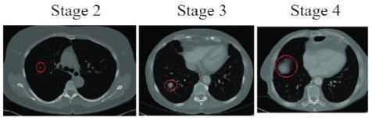
Fig no 3.1 Growth of a tumour during the various stages of Lung Cancer. Stages 2, 3 and 4 of lung cancer.

P. Chaturvedi's research [10] is the finest on this subject; it discusses the use of several imaging modalities, including CT, MRI, and X-ray scans, as well as the examination of biomarkers and odd patient complaints. Machine learning techniques like "Support Vector Machines" (SVM), "Convolutional Neural Networks" (CNN), image enhancement, and image processing are mentioned as ways to increase the accuracy and aid in the detection and categorisation process. The significance of various attributes in the dataset was also examined. Within the context of this specific topic, this study is the most directly connected work to the answer we are getting ready to provide.

One of the main areas of study for lung cancer prediction centres on asking a few questions regarding the symptoms of lung cancer in order to get a diagnosis. The issue with this method is that since the diagnosis is largely dependent on the patient's behaviour, the precision of such a prognosis cannot be applied to actual circumstances. Since each person's response is unique, these replies might not always be positive. Predicting the presence of carcinogens from CT scan pictures is another area of research on this subject. Despite producing reliable findings, this method requires a doctor to administer a CT scan at the time of diagnosis. Since the patient is never recommended to get a CT scan unless they are experiencing severe symptoms, this approach cannot be utilised for early-stage prediction. Under the direction of Dr. Ayyadurai and Mrs. Archana, who have extensive publication experience and have guided multiple students in their research, our team—Udit Krishna and Barath Lakshman, students at SRM Institute of Science and Technology—has developed a solution to this problem. They have a thorough understanding of various Machine Learning and computational intelligence technologies and have worked on multiple projects that are comparable to the current one.
Accurate lung cancer detection and early lung cancer detection for patients are the goals of this study. We start by asking the patient a series of questions about their symptoms, including coughing, wheezing, exhaustion, yellow fingers, etc., as well as enquiries about the the patient's medical history. After analysing the patient's responses, we classify their risk as low, medium, or high employing the Decision Tree Algorithm. We obtain the CT scan image if the patient is at medium or high risk. After processing this image, we use a custom VGG16 neural network with convolution to analyse it.
We can help patients in their early stages and improve the likelihood of a successful therapy by using this study to further confirm the kind of lung cancer. This double-step verification architecture presents a possible path to improving lung cancer treatment and maybe improving patient outcomes by surpassing current methods in diagnosis accuracy

Table 3.1: Parameters for lung cancer prediction.

Column Name | Description | Values
Age | The age of the patient. | 14-73  (Numeric)
Gender | The gender of the patient. | M-1F-2  (Categorical)
Air Pollution | The extent of the patient's exposure to air | 1-3
 | pollution. | 1-Lowest
Alcohol Use | The extent of the patient's usage of alcohol | 3-Highest
Dust Allergy | The extent of the patient's alertness to dust. | (Categorical)
Occupational | The extent of the patient's exposure to air
Hazards | pollution.
Genetic Risk | The extent of the patient's genetic susceptibility.
Chronic Lung | The degree of chronic lung disease experienced by
Disease | the patient.
Balanced Diet | The extent of a balanced diet followed by the
 | patient.
Obesity | The degree of obesity of the patient.
Smoking | The extent of the patient's smoking habits. | 1-3
Passive Smoker | The degree of second-hand smoke exposure | 1-Lowest
 | experienced by the patient. | 3-Highest
Chest Pain | The degree of chest pain experienced by the | (Categorical)
 | patient.
Coughing Blood | The degree of blood while coughing is
 | experienced by the patient.
Fatigue | The degree of fatigue experienced by the patient
Weight Loss | The extent of the patient’s recent weight loss.
Shortness of | The degree of shortness of breath experienced by
Breath | the patient.
Wheezing | The degree of wheezing experienced by the
 | patient.
Swallowing | The degree of swallowing difficulty experienced
Difficulty | by the patient.

Clubbing of Finger  Nails | The degree of clubbing of the fingernails  experienced by the patient.
Target Column | Severity of Cancer
Description | The level of severity of carcinogen found in the patient. (Categorical)
Values | Low, Medium, High

Materials and Methods
The two datasets required for the implementation of the proposed model were obtained from Kaggle. The dataset required for forecasting the severity of lung cancer using several characteristics and symptoms is provided by The Devastator, Lung Cancer Prediction, about the conditions of numerous patients and their diagnosed risk of cancer. This data feeds into the training process of a decision tree model to foresight the severity of the carcinogen found in the patient's body according to the following parameters (Table 1).
The software required is Python for Data Manipulation and Coding, Scikit Learn for the implementation of the “Decision Tree Classifier,” and Jupyter Notebook for the integrative Python document. The “Decision Tree Classification” is a supervised machine learning technique that builds a tree-like structure to use input characteristics to inform judgements. The terminal node in this tree architecture represents the class label, each branch represents a decision taken at that node, and each inner node represents a characteristic. Choice Trees are simple to understand and may be rapidly translated into a set of production rules. But when the tree is deep, this method tends to overfit. The decision tree method may have to investigate more possible splits as the total quantity of training samples increases, which would raise the computing complexity [11]. On the test set, the accuracy score of this model, which was developed using the training set, is 99.67%.

Table 3.2. Folder-wise Image Distribution.

- | Adenocarcinoma | LargeCell  Carcinoma | SquamousCell  Carcinoma | Normal
Train | 195 | 115 | 155 | 148
Valid | 23 | 21 | 15 | 13
Test | 120 | 51 | 90 | 54

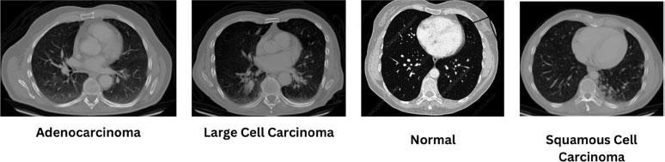
Fig no 3.2 :Sample image from each type of cancer.

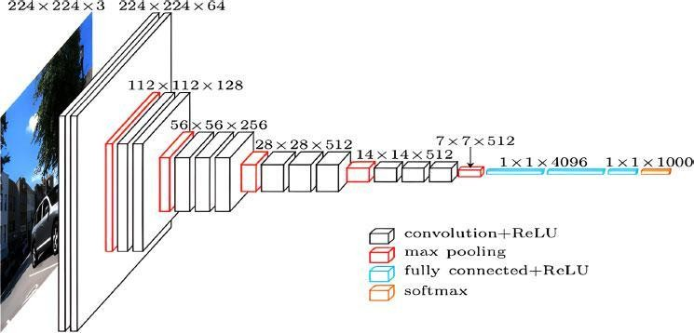
FIG NO 3.3 Convolution operation of H and F.

Mohamed Hany, Chest CT-Scan pictures Dataset, Version 1, Retrieved August 2023, provides the dataset needed to determine the kind of cancer in the lungs using the CT-Scan image. A customised "VGG16 Convolutional Neural Network" model is trained using this dataset to identify the three forms of lung cancer: "Adenocarcinoma," "Large Cell Carcinoma," "Squamous Cell Carcinoma," or the Normal Lung picture. Table 2 lists the picture categories that are included in this collection. Fig. (2) shows a rendition of a CT-Scan picture from each form of lung cancer. Python is needed for manipulation of data and coding, TensorFlow is needed for deep learning implementation and

convolutional neural network training, and “Artificial Neural Networks, also called ANN, can have fewer parameters by using "convolutional neural networks." Because of this, we are able to tackle complex problems that were previously impossible. The initial layers identify low-level, simpler traits, whereas subsequent layers identify high-level, complicated features. Every network layer improves on the output of the one before it, honing the data and eventually producing the intended result [12–14]. The formula for convolution of a 2-D picture "H" with a 2-D filter (kernel) "F" is shown in Fig. (3). The result is an output G[i, j], where "i" and "j" are the indices in the output matrix G that represent the rows and columns, and "u" and "v" are the indices that symbolise the quarters and columns of the image H, and ‘k’ represents the half-width of the filter F.
The "Visual Geometry Group" at the University of Oxford created the "VGG16" architecture, which makes use of these convolutional neural networks. The VGG16, which was created specifically for picture classification, is a significant milestone in the history of deep learning. Fig. (4) displays an example VGG16 model that was acquired from [12]. Our specially created Customised VGG16 model achieves 92.53% accuracy in the verification criteria set during training and 90.79% accuracy during testing.
To normalise the output of the basic VGG16 layers, we use Batch Normalisation [13] in the base VGG16 is the Neural Network Architecture. This can assist in preventing the model from being overfit. The pooling layer is then added to extract the most important characteristics. of the complex matrix, lowering the amount of information required for network training [14]. Figure 5 shows how the Max- Pooling layer functions and was taken from [14]. The matrix is now reshaped into a column by flattening it. Additionally, in order to minimise the output to 4 classes—the total number of output groups in our dataset—we could include Dense and Dropout. By performing matrix-vector multiplication, the Dense layer lowers the amount of outputs in the layers that follow and enhances the classification model's performance [15]. Dropouts entail deactivating a subset of the network's neurones at random. Both inward and outward connections are cut off when these neurones are silenced. This is carried out in order to improve the instructional experience of the [16] model. The image classification process for the sort of lung cancer found in the CT scan picture is carried out using the customised VGG16 model, which is displayed in Fig no . (3.4).

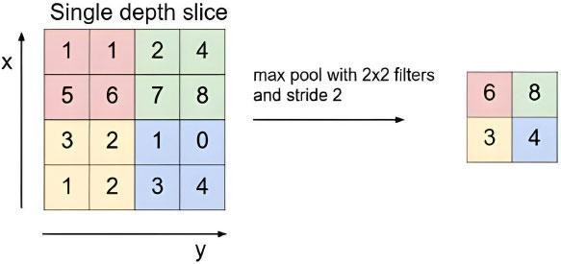
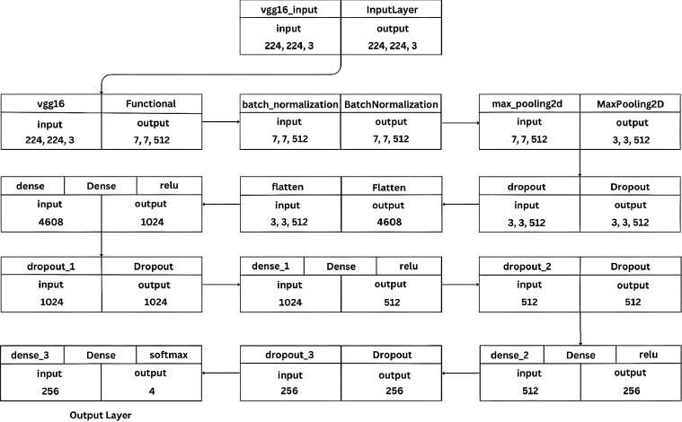
FIG NO 3.4 customised vgg16 cnn model architecture for lung cancer prediction.

Several preprocessing methods are used before feeding the model the training pictures. After being enlarged to 224,224 pixels with three colour channels, the photos are transformed to 32-bit floating- point values, which are a popular format for neural network models. Following this, the pictures are subjected to the preprocessing procedure unique to VGG16. The function converts RGB to BGR by switching the first and third channels. VGG16 was trained on pictures in the BGR, which is (Blue- Green-Red) channel order, although the majority of image libraries utilise RGB. Additionally, each channel's mean pixel values—derived directly from the ImageNet dataset used for VGG16 training— are eliminated, centring the pixel values around zero and enhancing model convergence during training [17]. Additionally, a number of data augmentation methods are utilised throughout this phase of preprocessing. During training, the pictures are randomly moved vertically by up to 20% of their height and rotated within a range of 10 degrees. The pictures are dynamically zoomed in or out by up to 20% after being tilted sideways by up to 20%. By producing altered copies of preexisting photographs, data augmentation artificially increases the size of the training dataset [18]. These methods aid in keeping

the model from being overfit. The model learns to better generalise to unknown data and avoid memorisation of certain visual patterns by being exposed to a wider variety of samples. Better real- world efficiency comes from the model's increased resilience to changes in picture orientation, location, size, and other transformations.
To provide the picture classification job a solid foundation, weights that have been trained from ImageNet will be added with the VGG16 model when it is instantiated. In order to facilitate feature extraction and transfer learning, the top completely linked layers are also eliminated. The VGG16 model's weights cannot be changed during training since each layer is frozen [19]. Transfer learning is frequently the main goal. The feature extraction capacities are utilised when a new classifier is added on top of the particular job by freezing pre-trained layers. When opposed to training a CNN from scratch, this saves time and money. Another use for the model is as a fixed feature extractor. Layer freezing allows for the extraction of significant elements from photos without changing previously learnt information. An Adam optimiser with a learning rate of 0.001 is used to train the model. One of the most used optimisers [20] for deep learning issues regulates the amount by which the model's weights are changed at each training stage. Accuracy is a statistic used to assess model performance during training. The model is constructed using the categorical crossing entropy loss function, which is used for categorising classification problems (many classes).

SYSTEM SPECIFICATIONS

Hardware Requirements: System: Pentium i3 Processor Hard Disk: 500 GB.
Monitor: 15’’ LED
Input Devices: Keyboard, Mouse Ram: 2 GB

Software Requirements: Operating System: Windows 10. Coding Language: Python 3.8 Web Framework: Flask

CHAPTER-4 SYSTEM DESIGN

Design Approach

By 2026, the machine learning system for energy usage in India would be designed using a layered, modular architecture that divides the system into distinct parts. In order to efficiently manage massive amounts of fuel-related data, make precise predictions, and provide insights via an intuitive user interface, the system design adheres to a modular, scalable, and information-centric architecture. Performance, maintainability, and adaptability are all balanced to meet changing needs.

Three main levels are the emphasis of the design strategy:

The Layer of Presentation

This layer, which was created with the Flask web framework, serves as the system's user interface. It makes it possible for users and administrators to communicate with the system using a web browser. The interface facilitates: • Web-based dashboards with Dash or React.js.

Supports filters, historical views, and data exports. Visualization of sentiment trends and hashtag activity
HTML, CSS, and Jinja2 templating are used for front-end rendering, ensuring the interface is both intuitive and responsive.

Application Layer (Business Logic)

This layer acts as the controller, managing interactions between the user interface and the underlying machine learning models. It is responsible for:

Prerocessing tweets (cleaning, tokenization, padding)Loading and applying the trained LSTM model Triggering exploratory data analysis routines (EDA)
Generating and rendering graphical insights such as word clouds and sentiment distribution graphs

All business logic is implemented in Python, leveraging libraries such as NLTK, spaCy, TensorFlow, Keras, and Matplotlib.

Data Layer

Data retrieval and storage are managed by the data layer. It facilitates the handling of both organised and unstructured data:
Unstructured Data: CSV or raw text formats are used to store and process tweets.
Structured Metadata: Relational database systems like Database or document-based archives like MongoDB may be used to handle data including sentiment scores, prediction outcomes, and use logs.
This division guarantees the effective management and autonomous scaling of user actions and tweet data.
Image Acquisition & Input Layer: Fundus photos (JPEG, PNG, DICOM) from tele-ophthalmology, mobile, and desktop cameras.
Upload Interface: Using web/mobile user interfaces or via REST API endpoints (/upload), users (technicians/clinicians) may choose or drag and drop photographs.

Preprocessing Module Standardisation:

Extract the green channel and resize/crop to a standard resolution (512 x 512 pixels, for example).

Improvement: Use Gaussian blur for noise reduction and CLAHE for brightness (per Reddit insights). Normalisation: Adjust pixel intensity and, if desired, hide areas that aren't important.

Data Augmentation Stage:
Methods for managing variability include translation, flipping, scaling, and rotation. CNN Module for Feature Extraction
Backbone: Fundus datasets are used to refine pretrained models (such as ResNet-18, GoogleNet/Inception, EfficientNet, and VGG). Additionally, custom CNNs (like CNN299/CNN512) are good choices.
Each image's intermediate deep feature vectors are the output.
Optional Dimensionality Reduction • PCA: Improve classifier performance by reducing feature vector
dimensionality to eliminate noise and redundancy.

Classification Module: XGBoost (with VGG16) or gradient-boosted ensembles are the alternatives. The main method is linear SVM for robust DR severity classification.
Multi-stage Fusion: For improved performance across several DR stages, combine CNN and transformer characteristics (e.g., HybridFusionNet).
Visibility & Interpretability

Heatmaps or Grad-CAM: Layer lesion light maps which indicate model emphasis regions, boosting clinician confidence.
Reporting & Output

Outcomes: visual heatmaps, confidence scores, and DR stage categorisation (No, Minor, Moderate, Serious and Proliferative).
Delivery: With automatic PDF/electronic report production, via UI monitor and REST API routes (/results). Logging and Data Management
Storage: Versioned models, audit trails, feature vectors, patient photos, model outputs, and system logs are all safely kept.
Security: using TLS and encrypt-at-rest protocols, HSV-compliant. Interoperability & Integration
Standards Compliance: Facilitates EHR/PACS connectivity via DICOM and HL7/FHIR interfaces.

User management: Authentication methods and role-based access (administrator, technician, and clinician).
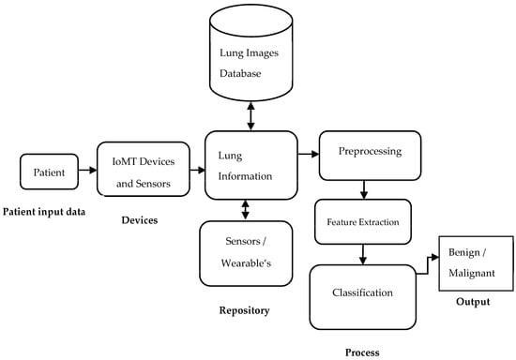

Fig( 4.1) System Architechture

Data flow diagram:

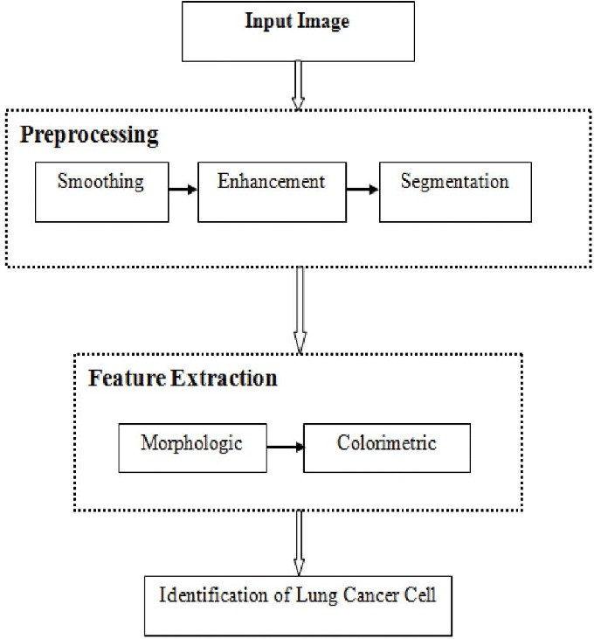
A data flow diagram is a visual representation of the data flow between different information system activities. It is among the most crucial tools for data modelling that aid in comprehending the architecture, its data, and its modifications connected to it. Additionally, it may illustrate any external organisations that collaborate with this system and demonstrate how they are responsible for the data change. It explains the input data for every system component, the transformations made to the input data, and what comes out as data from the system component to the input data. Additionally, it provides a rational understanding of the numerous business processes that are part of the system. To lower the degree of abstraction, display additional information related to each system component or process, and expound on the system's operation, the information in the structure diagram can be divided into many

.

Fig ( 4.2 ) Admin Data Flow Diagram

The DFD emphasises system configuration, user administration, and supervision from the administrator's point of view:
Outside Organisation

Administrative Procedures Verify the admin credentials.
Control User Roles: Add, edit, and remove users (clinicians, technicians).
Keep an eye on system logs to see audit trails, processing statuses, and picture uploads.
Control System Configuration: Modify model versions, preprocessing settings, and classifier thresholds. Create Reports: Compile use metrics and system performance data.
Information Storage User Database: Holds roles and user profiles. Configure Store: Stores thresholds and model parameters. Audit Logs: Monitors configuration modifications, admin operations, and login attempts. Flows of Data
Admin → Verify: Qualifications
Administrator → Configure Users: User profile information • Authenticate → Access Authorised Control Users → User Database
Logs → Audit Logs Admin → Evaluation Logs: Log queries
Admin → Update Config: Parameter updates Configuration -> Config Shop
Admin → Report
Generation: Requests for reports
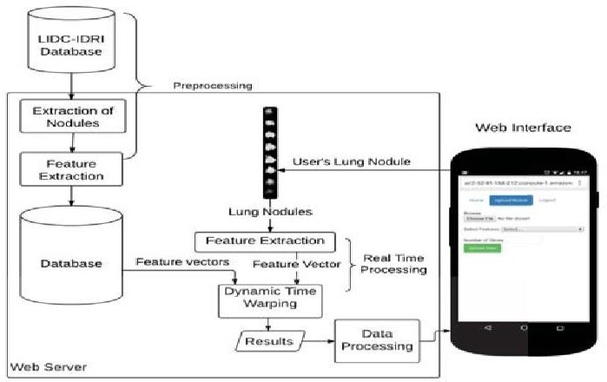

Fig( 4.3) Data Flow Diagram (DFD) — User View

The flow revolves around processing images and collecting diagnostic results from the perspective of the User (Clinician/Technician):
User (Technician/Clinician) • External Entity

Procedures
Log in or verify the user Provide the Fundus Image
Image preprocessing includes denoising, cropping, and CLAHE. Feature Extraction: CNN is used to compute deep features.
Classification: The DR stage is predicted using a hybrid model (SVM/XGBoost). Create a Grad CAM heatmap to visualise the results.
Display Output: Provide visualisation, categorisation, and confidence.
Send Feedback: Users can report incorrect categorisation or poor image quality.. Data Stores
Image Store – Raw and preprocessed fundus images. Feature Store – Extracted feature vectors.
Model Store – Classifier and model versions.
Results Store – Diagnosis results, heatmaps, and feedback. Data Flows
User → Authenticate: Username/password
Authenticate → Provide Access User → Upload: Fundus image Image → Image Store
Image Store → Preprocess: Preprocessing pipeline
Preprocessed Image → Image Store
Image Store → Feature Extraction: Triggers CNN model
Features → Feature Store
Feature Store → Classification: Classifier predicts DR
Prediction → Results Store
Results → Visualization: Grad-CAM overlay
User ← Display Result: View outputs and visuals User → Provide Feedback: Quality flags or overrides Feedback → Results Store

UML DIAGRAMS

The full form of UML is a unified modeling language. It is a set of standards created for modeling and visualizing the elements and components of a software system. It is mostly used in the field of object-oriented software programming. The main agenda of UML used to be a general language for creating models for any software system. UML has two main components: A meta-model and a notation. It is a compilation of best engineering and business practices that have been successful over the years for modeling systems that are large and complex. The design of software projects is expressed as graphical notations using UML.
Goals:

The main goals of UML for the design of systems as mentioned below:

1To be a graphically expressive modeling language that can be ready to use.

    - To be extendable and provide special mechanisms or techniques to expand the scope of core concepts.

    - It should not be dependent on any programming language our development process

    - To acts as a basis for understanding any other modeling languages

    - As it is dependent on object-oriented programming principles it aims to increase the market of objectoriented programming tools.
    - It aims to provide for a higher level of development concepts such as frameworks, patterns, etc

    - It aims to integrate the best practices to learn over the years and innovate for future developments

USE CASE DIAGRAM:

A use case diagram corresponds to a behavioural diagram created from a use instance investigation inthe unified programming language. The main goal of the usage scenario diagram is to graphically depict how the system functions in relation to its users. It accomplishes this by demonstrating which characters perform certain duties or functions and how this affects the system as an entire thing.

Use Case Diagram:

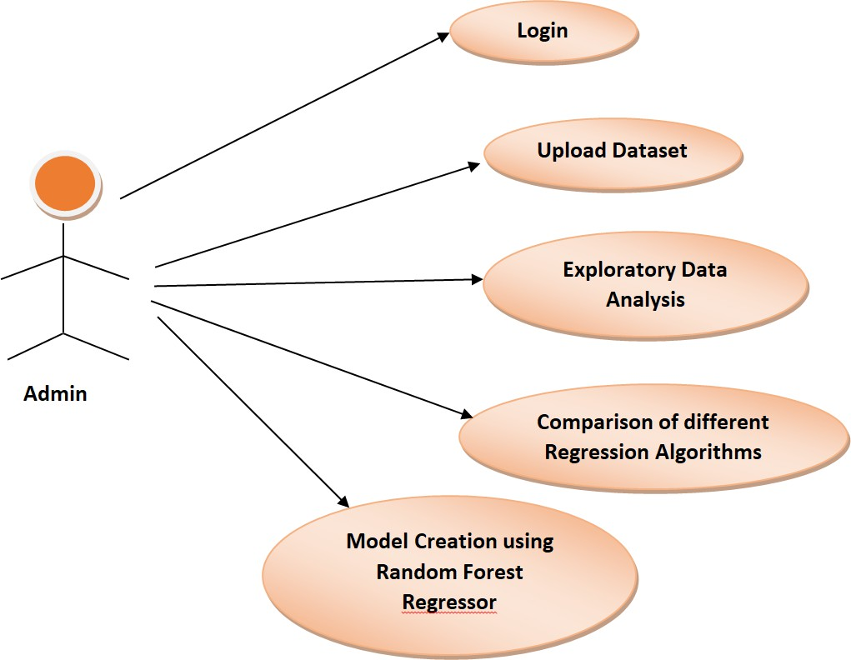

Fig (4.4). Use Case Diagram Admin

Use Case Diagram:

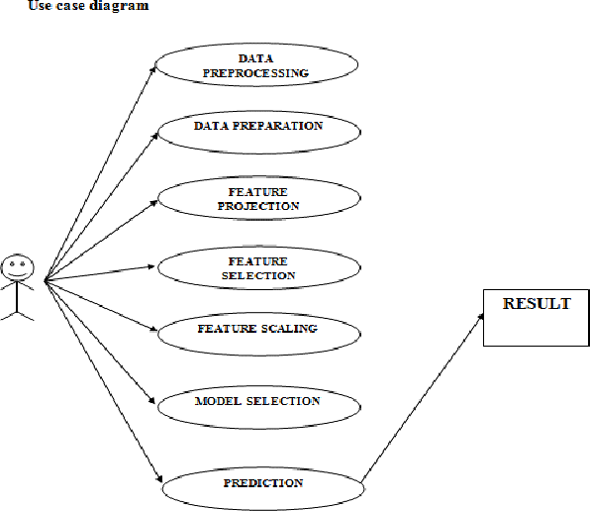

Fig (4.5). Use Case Diagram.

SEQUENCE DIAGRAM:
To illustrate how processes interact with other processes and in what order, a sequence diagram is made using the unified modelling language. Sequence diagrams, sometimes called timing diagrams or occurrence diagrams, are used to show the sequence or order of events that occur sequentially in a system. It lists the parties, the transactions that must take place in order for the capability to perform, and the order in which they must occur.

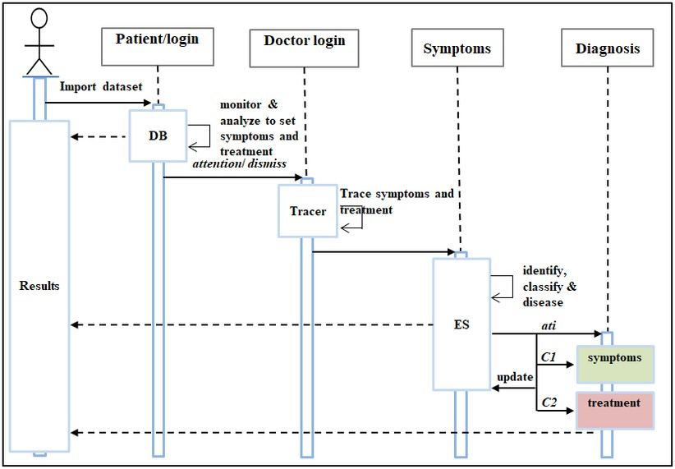
Fig ( 4.6 ) Sequence Diagram

CHAPTER-5 IMPLEMENTATION AND MODULES
The project's suggested modular implementation is shown below. It includes the modules listed below: Admin User Module: The system administrator is in charge of the following tasks:
- Putting the dataset online
- Lung cancer dataset analysis.
- Conduct exploratory data analysis, feature engineering, and data pretreatment tasks.
- Evaluation of several machine learning techniques using the lung cancer dataset
- Examine how well different regression techniques work on the provided dataset.
- Use the Random Forest Regressor to create a model that forecasts the cost of lung cancer. Module for Users:
The following tasks can be completed by the user:
- Enter the system.
- Type in the information on lung cancer.
- Obtain estimates for the price of lung cancer

Methodologies
PYTHON: Python 3.8 is being used for application development in this project. Unlike other programming languages, Python does not need the acquisition of specific syntax, making it a highly straightforward and powerful language to learn. Simple English and the Python computer language share a lot of similarities in grammar. It can do intricate tasks and enable object-oriented programming. compute mathematically and put machine learning methods into practice. Its typing dynamically and structure of information enable the quick construction of applications. Because Python contains more English terms than any other programming system and is easily understood by the general public, it is regarded as a highly accessible language. Python has become well-known and is utilised in many cutting-edge fields and technological platforms as a result of the exponential growth of data and the introduction of big data technologies. Because the Python interpreter analyses the code in runtime, a compiler is not necessary to check for syntactical errors and build the code.
It is compatible with all operating systems and offers a vast collection of standard applications and packages that are used to carry out different tasks. It is a readily readable, learnable, extensible, and maintainable language. One may connect to the majority of the significant databases that are now in use and accessible

on the market by using Python as the programming language. With the use of GI programming, it provides support for operating systems and building web applications. It is the only programming language that allows for the creation of programs using object-oriented, structural, and functional approaches. Python code supports garbage collection and may be readily integrated with other computer languages.

Flask
FLASK: This framework for web applications allows developers to create lightweight web applications. It gives Python access to its libraries. The WSGI toolkit The flask web application framework is built on top of the Andy Jinja 2 template engine. Flask is regarded as a microframework because to its low weight. The WSGI toolkit is a global protocol and interface that implements web objects like as requests, responses, and other useful services. Python has adopted it as a standard for creating web applications. For web server and web application communication, it is the standard interface definition. Jinja 2 is a popular Python templating engine. It is used to build dynamic online content by combining templates with various types of data sources. Flask's architecture makes it easy to create web apps since it makes the basic application development process relatively straightforward. It lacks built-in abstraction layers for support of form validation and database connectivity. Nonetheless, flask can be used to accomplish all of these features. Thusflask is a straightforward web framework that may be expanded.

PyCharm
After the application is formed, the routing logic can be written in the app.py file and HTML pages may be added to the templates folder. Then, in order to browse to the correct URLs and carry out the necessary functions, one may link their views to the routes.
Nonetheless, the website may include several modules, user roles, and user functionality such as database connectivity, validation, error handling, etc. It is impossible to maintain a huge app.py file and write everything in it. For any coder, it would be a tiresome chore.

The ideal answer to this problem is provided by blueprints. The code may be arranged into several modules using blueprints. Multiple view files can be used to write the code, and a blueprint object can be created for each of them. Any routing logic described in the prototype may be run without any issues if this blueprint object is registered on the app.py file. This makes code organisation a breeze and makes it possible to create huge, easily maintained flask apps. One of the most potent Python programming environments (IDEs) is

PYCHARM Professional, created by JetBrains. It is intended to improve efficiency, optimise development processes, and provide expert developers access to a wide range of tools. PyCharm Professional provides a feature set that enhances the efficiency and enjoyment of coding, regardless of whether you're working on enterprise-level software, data science projects, or web apps.

Important attributes and capabilities

- Help with Intelligent Code

To assist developers in writing clear and effective code, PyCharm Professional offers smart code completion, syntax highlighting, and error detection. Because of its extensive knowledge of Python, the IDE provides context-aware recommendations that increase coding correctness and speed.

- Sophisticated Tools for Testing and Debugging

An essential component of programming is debugging, and PyCharm is excellent at it.

Integrated testing frameworks like PyTest and UnitTest, which let developers create and run tests with ease; Graphical Debugger with breakpoints and variable examination;
Remote Debugging for debugging applications operating on distant servers.

- Integration of Version Control

With PyCharm Professional's support for Git, Mercurial, and Subversion, developers can effectively manage their code repositories. The IDE comes with built-in features including branch management, commit history, and dispute resolution.

- Support for Databases and SQL

With the help of PyCharm's built-in database tools, developers can run SQL queries right within the IDE, browse and edit database schemas, and connect to PostgreSQL, MySQL, Oracle, MongoDB, and Redis.

- Proficiency in Web Development

In addition to Python, PyCharm Professional supports HTML, CSS, JavaScript, TypeScript, and well-known web frameworks like Flask and Django. It is therefore a great option for full-stack development.

- Analysis and Refactoring of Code

It's crucial to keep code neat and effective, and PyCharm offers

strong refactoring tools like: Rename variables and functions across the project; Extract constants and methods to make the code easier to read.

PEP 8 compliance tests to make sure Python code standards are followed. 7 AI-Powered Help with Coding
Context-aware code completion, clever refactoring advice, and smooth interaction with Jupyter notebooks are just a few of the AI-powered features that JetBrains has included into PyCharm.

Increases in Productivity

- Adaptable themes and user interface

To provide a comfortable writing experience, PyCharm gives developers the ability to alter the interface, including themes, fonts, and key bindings.

- Ecosystem of Plugins

With the help of the extensive plugin library supported by the IDE, developers may expand functionality to suit their own requirements.

- Development from a Distance

Developers may work on distant projects without installing dependencies locally thanks to support for SSH and Docker.

- Tools for Profiling

Performance profiling tools are included in PyCharm to assist developers in examining code execution and improving performance.
For projects including machine learning (ML), deep learning (DL), and artificial intelligence (AI), PyCharm Professional is a robust integrated development environment (IDE). It is a great option for data scientists and AI developers since it easily interfaces with well-known machine learning frameworks and tools.
Important Elements for the Development of ML, DL, and AI
- Integrated Scientific Instruments
With features like Conda compatibility, a REPL Python interface, and Jupyter Notebook integration, PyCharm Professional enables developers to work effectively with data science processes.
- Assistance with Well-Known ML/DL Libraries
Major ML and DL libraries are supported by the IDE, such as PyTorch for neural networks and AI research as well as TensorFlow and Keras for deep learning.

For conventional machine learning techniques, use Scikit-learn; for data processing, use NumPy and Pandas; and for data visualisation, use Matplotlib and Seaborn.

- Assisting with Intelligent Code

PyCharm ensures effective coding practices by offering smart code completion, error detection, and refactoring tools designed for ML and AI applications.

- Cloud Integration and Remote Development

SSH, Docker, and WSL allow developers to operate on distant servers, which facilitates model training on potent cloud-based GPUs.

- Combined Data Management and Database

For AI applications, PyCharm's support for SQL databases, MongoDB, and Redis enables smooth data storage and retrieval.

- Code Assistance Driven by AI

PyCharm now adds AI-powered features from JetBrains, including intelligent debugging for machine learning workflows and context-aware code completion.

Algorithms

Traditional Machine Learning Algorithms
Linear Regression
The goal is to simulate the connection amongst the consumption of fuel and continuous predictors such as load, speed, and distance travelled by the vehicle.
Why It's Used: It works well for linear connections and is easy to understand.
- The goal of Random Forest is to manage intricate, non-linear connections between a number of characteristics and fuel usage.
Why Used: the random forest method works well on a wide range of characteristics, is resilient, and minimises overfitting.
- Gradient Boosting (XGBoost / LightGBM): This technique uses a group of weak models to build a stronger model in order to estimate fuel usage with greater accuracy.
Why Used: XGBoost and the LightGBM are very effective, quick, and excel at handling categorical variables in regression tasks.
- Support Vector Machines ( SVM ) Goal: To forecast fuel usage when information may have a more complex boundary.
Why Used: SVM works well for classification and regression tasks, especially when there is a high- dimensional feature space.

Deep Learning Algorithms
aNetworks using short-term and long-term memory (LSTM)
The goal is to use historical data to simulate time-series data, such as trends in fuel usage over time.
Why Used: Sequential data and dependency over time are crucial for fuel consumption predictions, and LSTM networks are especially well-suited for managing these types of data.
c. Networks of neurones
The goal is to identify complex relationships in gasoline consumption data and make predictions based on a variety of variables, including weather, road type, and engine performance.
The rationale for the use of neural networks is their capacity to manage huge, non-linear datasets with several interdependent factors.

Models that are hybrid
The goal is to increase prediction accuracy, particularly in complicated scenarios involving both periods of time and non-time-series variables, by combining models such as Random Forest in SVM or XGBoost with LSTM.
Why Used: By using the advantages of many techniques, hybrid models guarantee improved performance across a range of data patterns.

Metrics for Model Evaluation
The average of the total variances between the expected and actual values is measured by the mean absolute error, or MAE.
Larger mistakes are given greater weight by the Mean Squared Error (MSE), which is helpful when significant differences are especially undesired.
To assess how effectively the model accounts for the variation in the gasoline consumption data, use the coefficient of determination, or R².

Sample Code:
Lung_Mobilenet.py
# Import necessary libraries import numpy as np
import warnings warnings.filterwarnings('ignore') import matplotlib.pyplot as plt import tensorflow as tf
from sklearn.utils.class_weight import compute_class_weight
from tensorflow.keras.preprocessing.image import ImageDataGenerator from tensorflow.keras.applications import InceptionV3, MobileNetV2 from tensorflow.keras.models import Sequential
from tensorflow.keras.layers import Dense, Dropout, SpatialDropout2D, Activation, Lambda, Flatten, LSTM
from tensorflow.keras.layers import Conv2D, MaxPooling2D, GlobalAveragePooling2D
from tensorflow.keras.callbacks import ReduceLROnPlateau, EarlyStopping, ModelCheckpoint

from tensorflow.keras.preprocessing.image import img_to_array, load_img import seaborn as sns
import matplotlib.pyplot as plt
from sklearn.metrics import confusion_matrix, classification_report, roc_curve, auc, precision_recall_curve from sklearn.preprocessing import label_binarize

def save_report_as_image(report, image_path): # Create a figure
fig = plt.figure(figsize=(10, 5))
plt.text(0.1, 0.5, report, fontsize=12, family="monospace") plt.axis('off') # Remove axes
plt.title("Classification Report") plt.tight_layout()
# Save the figure
plt.savefig(image_path, bbox_inches='tight') plt.close(fig)

def plot_confusion_matrix(conf_matrix, file_name): plt.figure(figsize=(8, 6))
sns.heatmap(conf_matrix, annot=True, fmt="d", cmap="Blues", xticklabels=True, yticklabels=True) plt.title("Confusion Matrix")
plt.xlabel("Predicted Labels") plt.ylabel("True Labels") plt.savefig(file_name, bbox_inches="tight") plt.close()

def create_model():

# Define paths to the training, validation, and test datasets train_folder = '../Lung Cancer Dataset/train'
test_folder = '../Lung Cancer Dataset/test' validate_folder = '../Lung Cancer Dataset/valid'

# Define paths to the specific classes within the train dataset normal_folder = '/normal'
adenocarcinoma_folder = '/adenocarcinoma' large_cell_carcinoma_folder = '/large.cell.carcinoma' squamous_cell_carcinoma_folder = '/squamous.cell.carcinoma'

# Load and preprocess data IMAGE_SIZE = (350, 350)
train_datagen = ImageDataGenerator(rescale=1. / 255, horizontal_flip=True) test_datagen = ImageDataGenerator(rescale=1. / 255)
# Define the batch size for training batch_size = 8

train_generator = train_datagen.flow_from_directory( train_folder,
target_size=IMAGE_SIZE, batch_size=8, class_mode='categorical'
)

validation_generator = test_datagen.flow_from_directory( validate_folder,
target_size=IMAGE_SIZE, batch_size=8, class_mode='categorical', shuffle=False

)

# Get class indices and labels
class_indices = train_generator.class_indices # e.g., {'normal': 0, 'doubtful': 1, ...}
classes = list(class_indices.values()) # [0, 1, 2, 3, 4]

# Get class labels for each sample train_labels = train_generator.classes print(train_labels)

# Compute weights
class_weights = compute_class_weight( class_weight='balanced', classes=np.unique(train_labels), y=train_labels
)

# Convert to dictionary format required by Keras class_weight_dict = dict(enumerate(class_weights)) print("Computed class weights:", class_weight_dict)

learning_rate_reduction = ReduceLROnPlateau(monitor='loss', patience=5, verbose=2, factor=0.5, min_lr=0.000001)

early_stops = EarlyStopping(monitor='loss', min_delta=0, patience=6, verbose=2, mode='auto') checkpointer=ModelCheckpoint(filepath='../models/best_mnet_lc_model.hdf5',verbose=2,save_best_only= True, save_weights_only=True)

checkpoint_cb=ModelCheckpoint('../models/mnet_lc_model.h5',save_best_only=True,monitor='val_accura cy',
mode='max', verbose=1)

# Define the number of output classes OUTPUT_SIZE = 4
validation_steps = validation_generator.samples

# Load a pre-trained model (Xception) without the top layers and freeze its weights
#pretrained_model = tf.keras.applications.Xception(weights='imagenet', include_top=False,input_shape=[*IMAGE_SIZE, 3])
pretrained_model = MobileNetV2(include_top=False, weights='imagenet', input_shape=[*IMAGE_SIZE, 3])
pretrained_model.trainable = False

# Create a new model with the pre-trained base and additional layers for classification model = Sequential()
model.add(pretrained_model) model.add(GlobalAveragePooling2D()) model.add(Dense(OUTPUT_SIZE, activation='softmax'))

print("Pretrained model used:") pretrained_model.summary()

print("Final model created:") model.summary()

# Compile the model with an optimizer, loss function, and evaluation metric model.compile(optimizer='adam', loss='categorical_crossentropy', metrics=['accuracy'])

# Train the model with the training and validation data generators

history = model.fit( train_generator, steps_per_epoch=25, epochs=50,
callbacks=[learning_rate_reduction, early_stops, checkpointer,checkpoint_cb], validation_data=validation_generator,
class_weight=class_weight_dict
)

# Get true labels and predictions from validation generator validation_generator.reset()
y_true = [] y_pred_probs = []

for _ in range(len(validation_generator)):
X_batch, y_batch = validation_generator.next() y_true.extend(np.argmax(y_batch, axis=1)) y_pred_probs.extend(model.predict(X_batch))

y_true = np.array(y_true)
y_pred_probs = np.array(y_pred_probs) y_pred = np.argmax(y_pred_probs, axis=1)

print("Final training accuracy =", history.history['accuracy'][-1]) print("Final testing accuracy =", history.history['val_accuracy'][-1])

# --- 1. Confusion Matrix ---
cm = confusion_matrix(y_true, y_pred) plt.figure(figsize=(8, 6))
sns.heatmap(cm, annot=True, fmt="d", cmap="Blues", xticklabels=class_indices.keys(), yticklabels=class_indices.keys())

plt.title("Confusion Matrix") plt.xlabel("Predicted") plt.ylabel("True") plt.savefig("../static/vis/mnet_cnf.jpg") plt.close()

# --- 2. Classification Report ---
report = classification_report(y_true, y_pred, target_names=class_indices.keys()) print(report)
# with open("../plots/classification_report.txt", "w") as f:
# f.write(report)
save_report_as_image(report, "../static/vis/mnet_clfrpt.png")

# --- 3. ROC Curve ---
y_true_bin = label_binarize(y_true, classes=np.arange(OUTPUT_SIZE)) fpr = dict()
tpr = dict() roc_auc = dict()

plt.figure(figsize=(8, 6))
for i in range(OUTPUT_SIZE):
fpr[i], tpr[i], _ = roc_curve(y_true_bin[:, i], y_pred_probs[:, i]) roc_auc[i] = auc(fpr[i], tpr[i])
plt.plot(fpr[i], tpr[i], label=f"Class {list(class_indices.keys())[i]} (AUC = {roc_auc[i]:.2f})")

plt.plot([0, 1], [0, 1], "k--")
plt.xlabel("False Positive Rate") plt.ylabel("True Positive Rate") plt.title("ROC Curve") plt.legend()
plt.savefig("../static/vis/mnet_roc.jpg")

plt.close()

# --- 4. Precision-Recall Curve --- plt.figure(figsize=(8, 6))
for i in range(OUTPUT_SIZE):
precision, recall, _ = precision_recall_curve(y_true_bin[:, i], y_pred_probs[:, i]) plt.plot(recall, precision, label=f"{list(class_indices.keys())[i]}")

plt.xlabel("Recall") plt.ylabel("Precision") plt.title("Precision-Recall Curve") plt.legend() plt.savefig("../static/vis/mnet_prc.jpg") plt.close()

# --- 5. Training vs Validation Accuracy --- plt.figure(figsize=(8, 6)) plt.plot(history.history['accuracy'], label="Training Accuracy") plt.plot(history.history['val_accuracy'], label="Validation Accuracy") plt.xlabel("Epoch")
plt.ylabel("Accuracy") plt.title("Accuracy Curve") plt.legend()
plt.savefig("../static/vis/mnet_train_val_acc.jpg") plt.close()
# --- 6. Training vs Validation Loss --- plt.figure(figsize=(8, 6)) plt.plot(history.history['loss'], label="Training Loss")

plt.plot(history.history['val_loss'], ] label="Validation Loss") plt.xlabel("Epoch") plt.ylabel("Loss")
plt.title("Loss Curve") plt.legend()
plt.savefig("../static/vis/mnet_train_val_loss.jpg") plt.close()
# Save the trained model model.save('../models/mnet_trained_lung_cancer_model.h5')
create_model()

CHAPTER -6

RESULTS SCREEN SHOTS
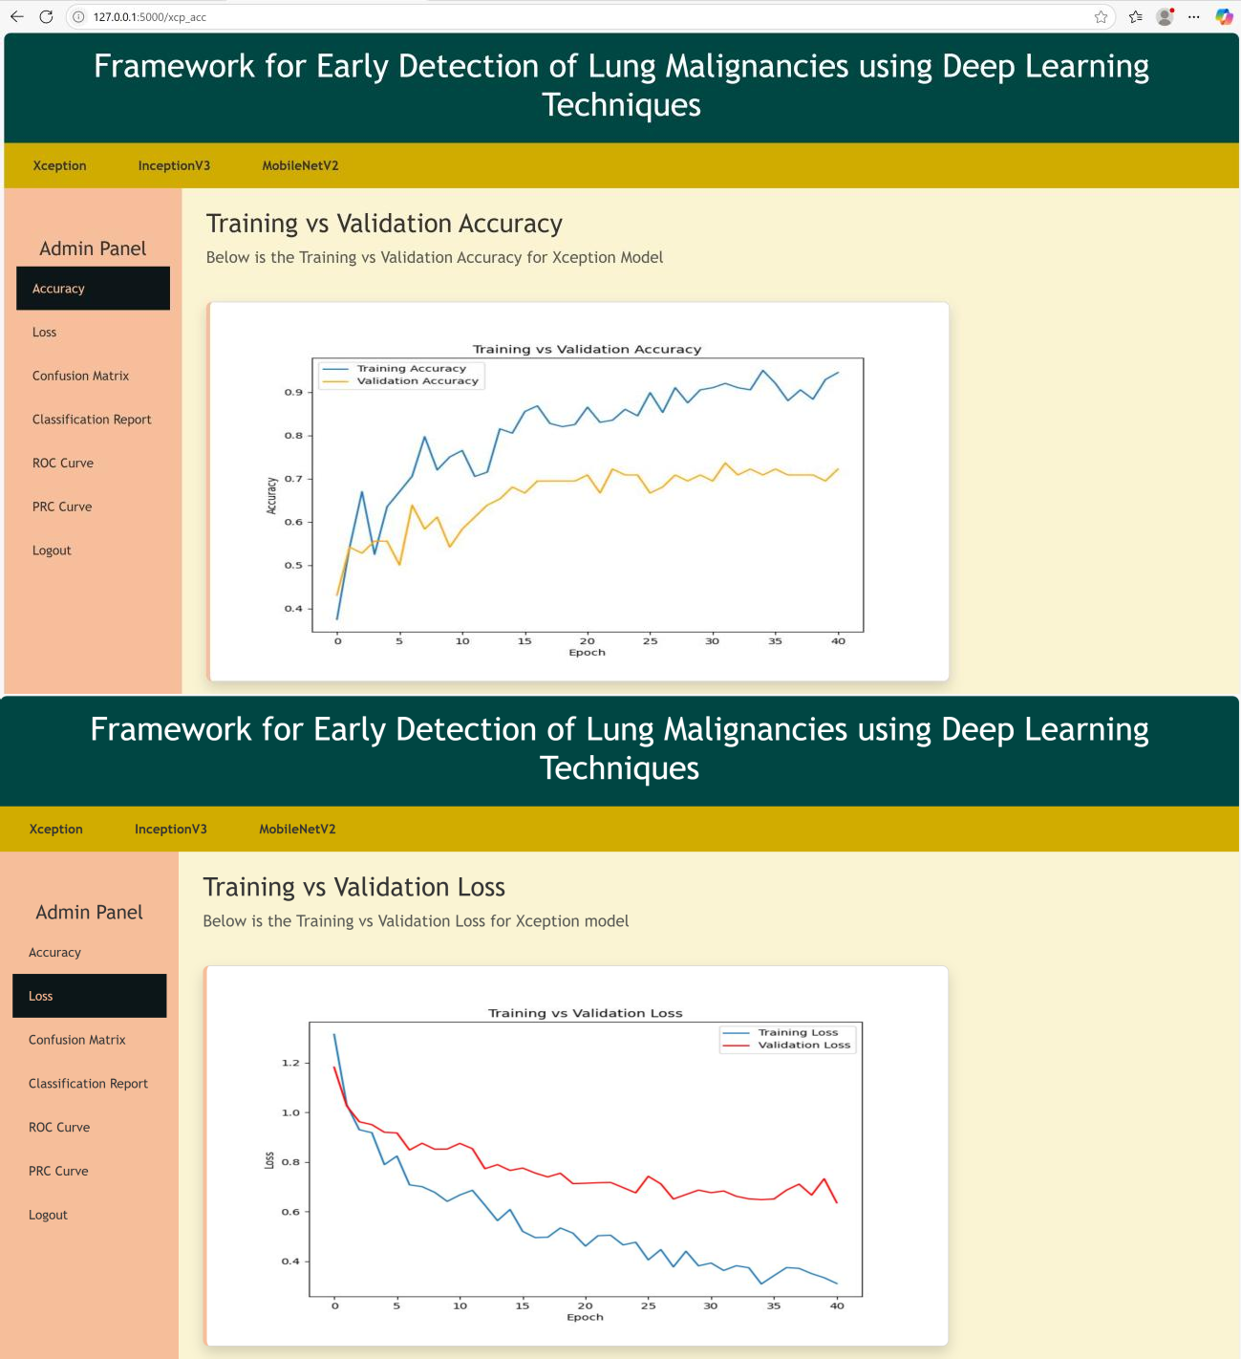
Fig no ( 6.1) Performance Metrics for Xception Model: (a) Training vs Validation Accuracy,
(b) Training vs Validation Loss

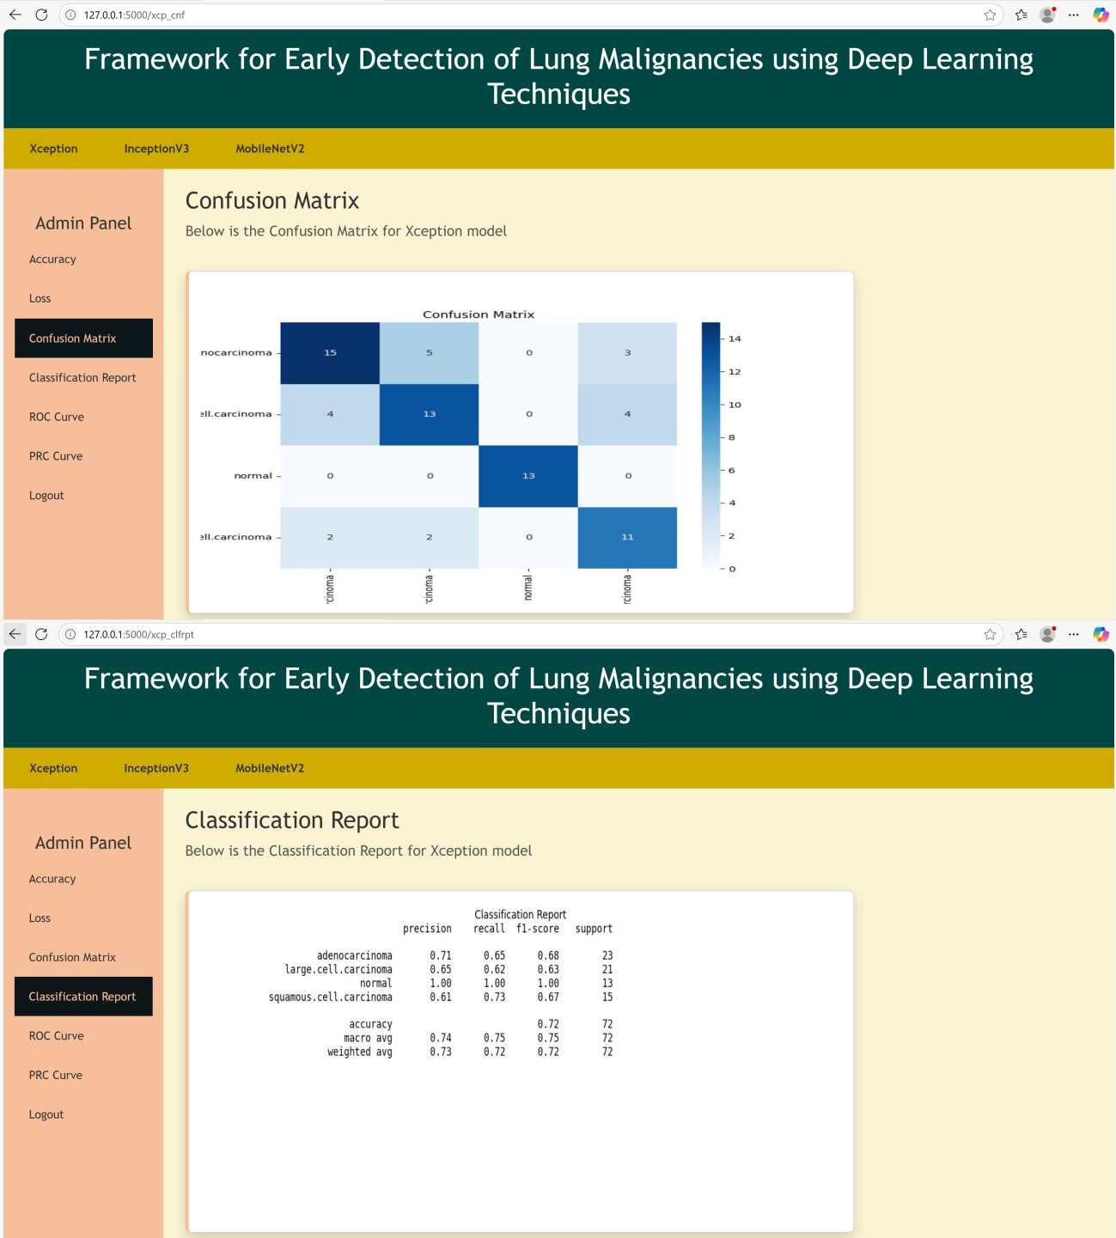
Fig no ( 6.2 ) Evaluation Results for Xception Model: (a) Confusion Matrix, (b) Classification Report

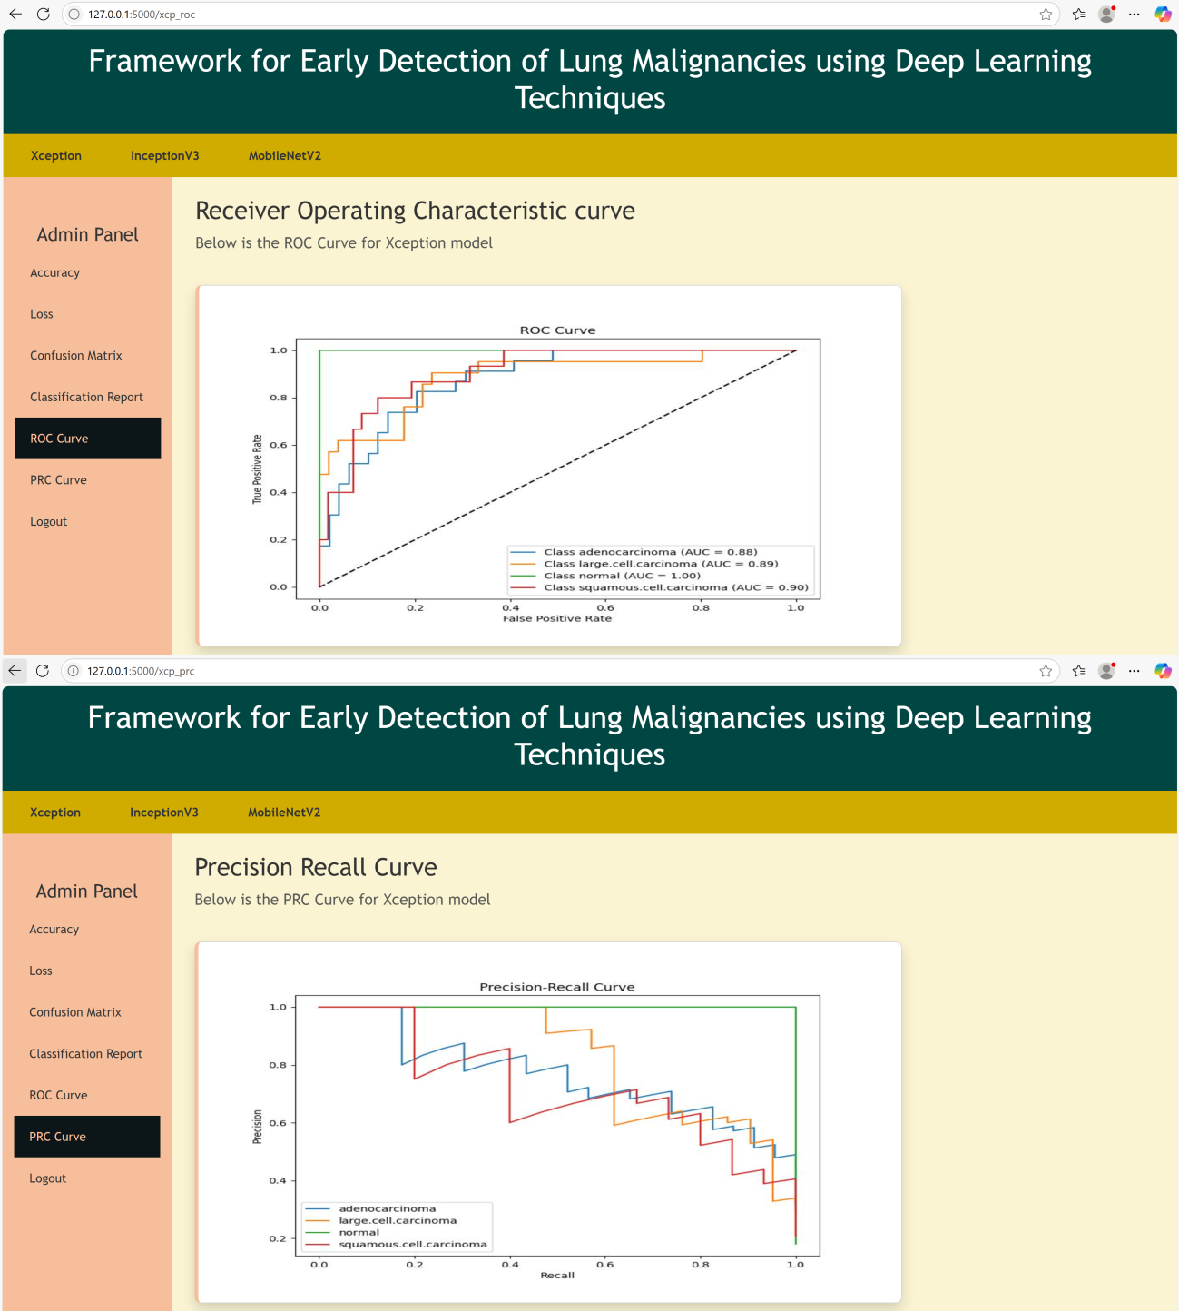
Fig no ( 6.3) Statistical Analysis for Xception Model: (a) Receiver Operating Characteristic (ROC) Curve, (b) Precision-Recall Curve (PRC)

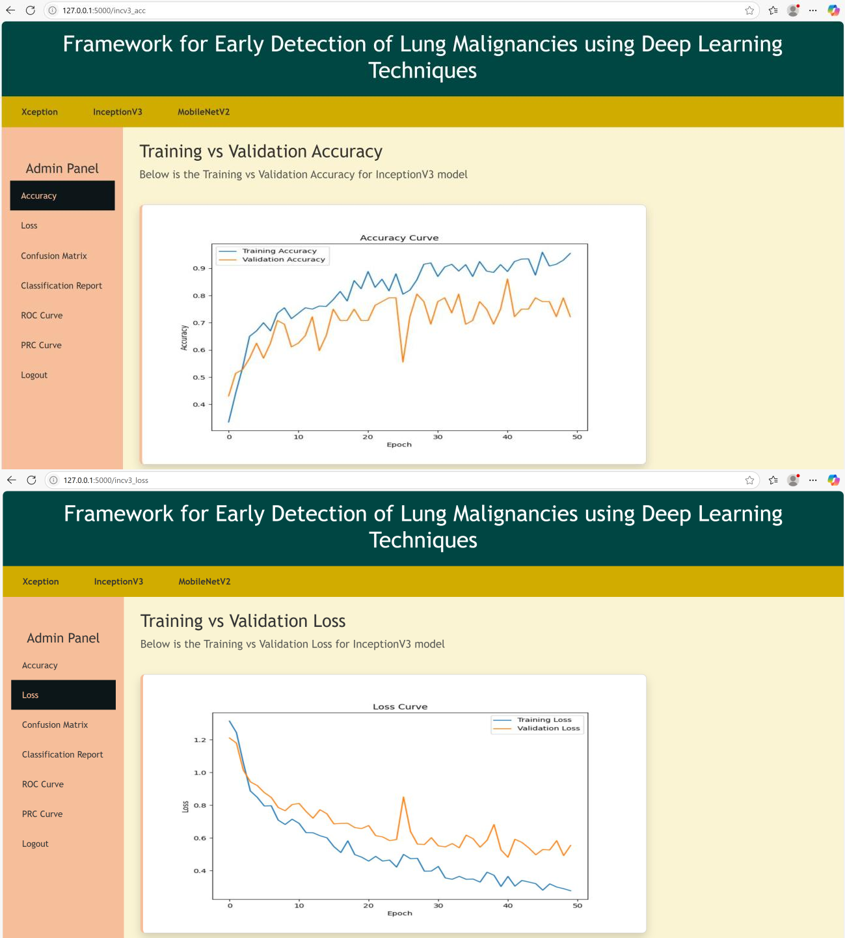
Fig no( 6.4) Performance Metrics for InceptionV3 Model: (a) Training vs Validation Accuracy,
(b) Training vs Validation Loss

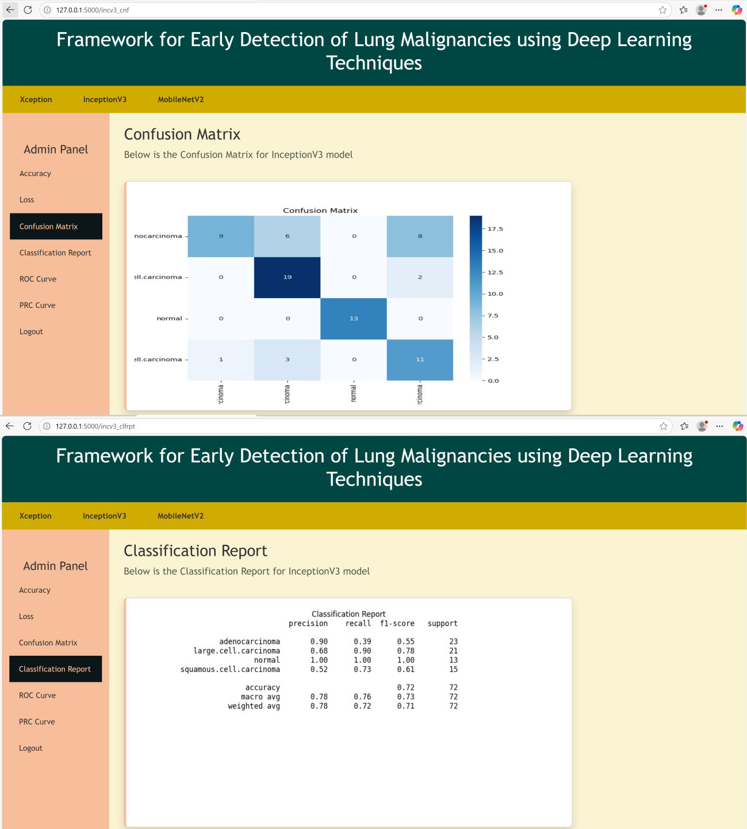
Fig no( 6.5) Evaluation Results for Xception Model: (a) Confusion Matrix, (b) Classification Report

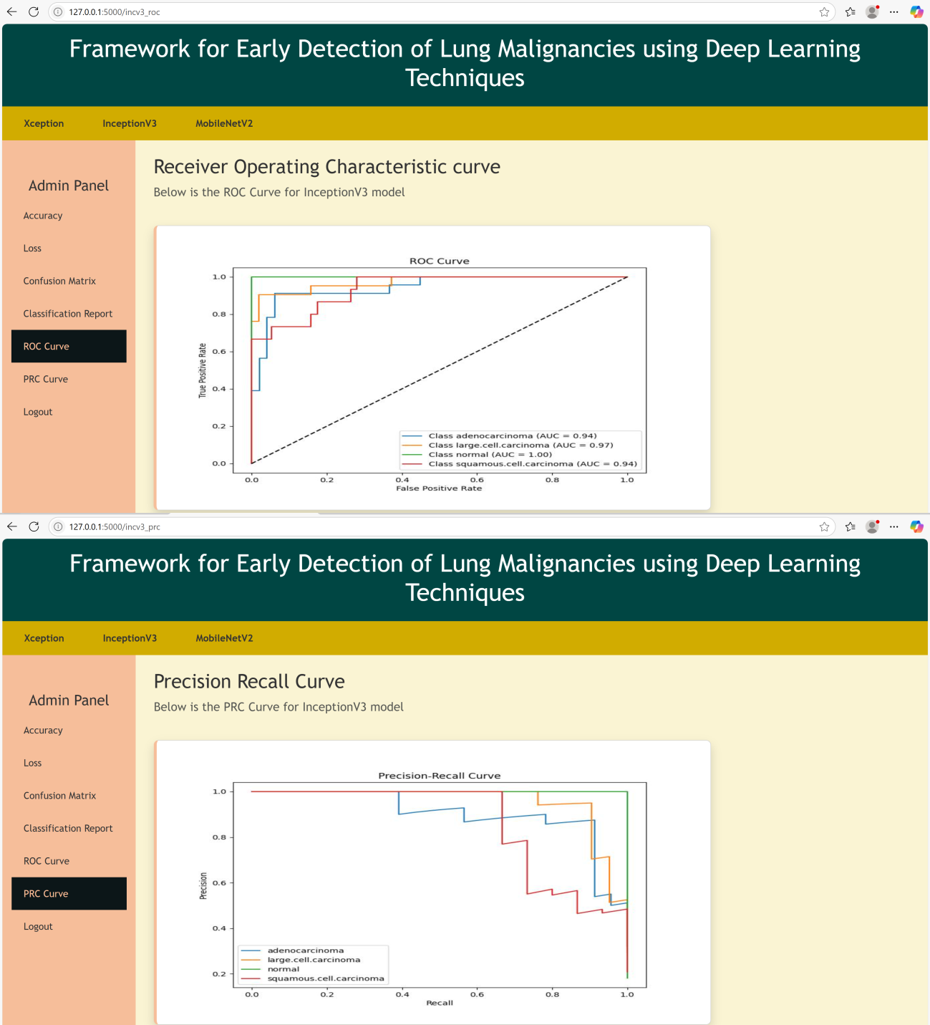

Fig no( 6.6) Threshold-Based Metrics for InceptionV3 Model: (a) Receiver Operating Characteristic (ROC) Curve, (b) Precision-Recall (PRC) Curve

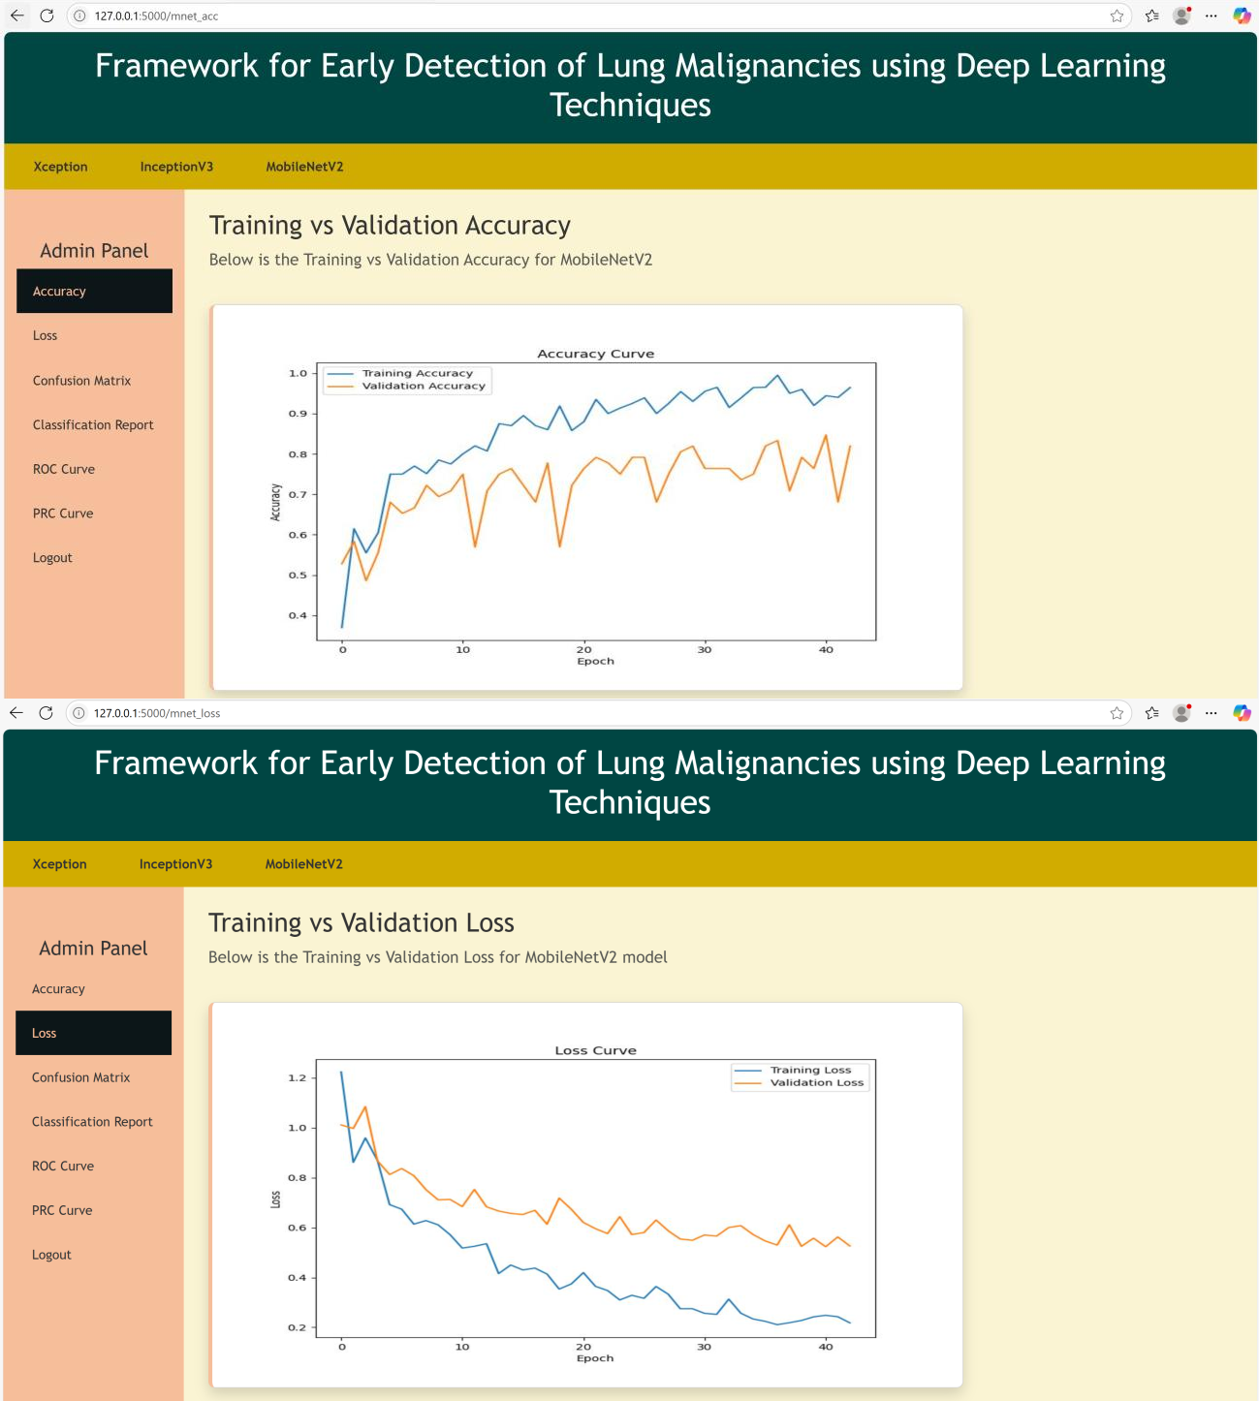
Fig no( 6.7) Performance Metrics for MobileNetV2 Model: (a) Training vs Validation Accuracy, (b) Training vs Validation Loss

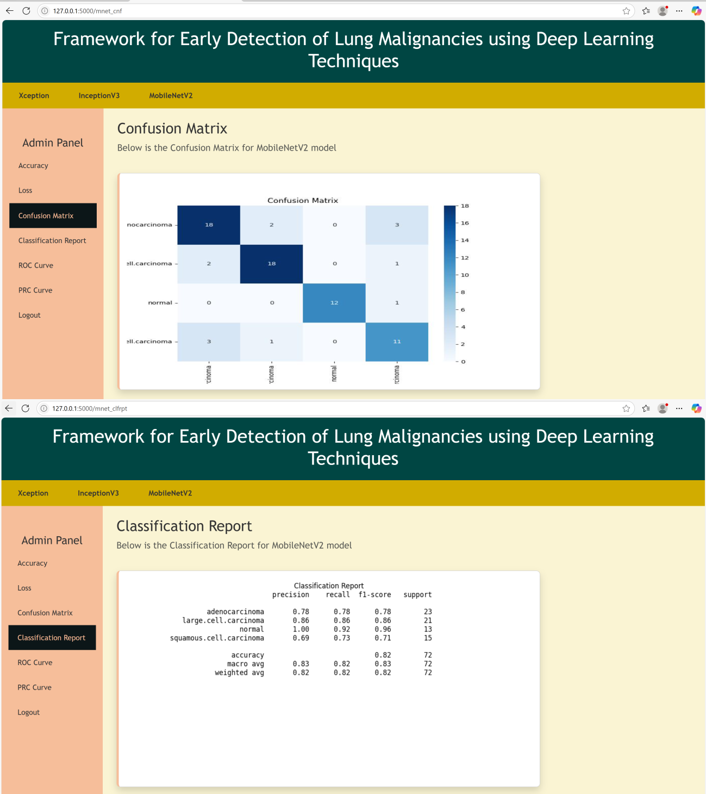
Fig no( 6.8 ) Evaluation Results for MobileNetV2 Model: (a) Confusion Matrix, (b) Classification Report

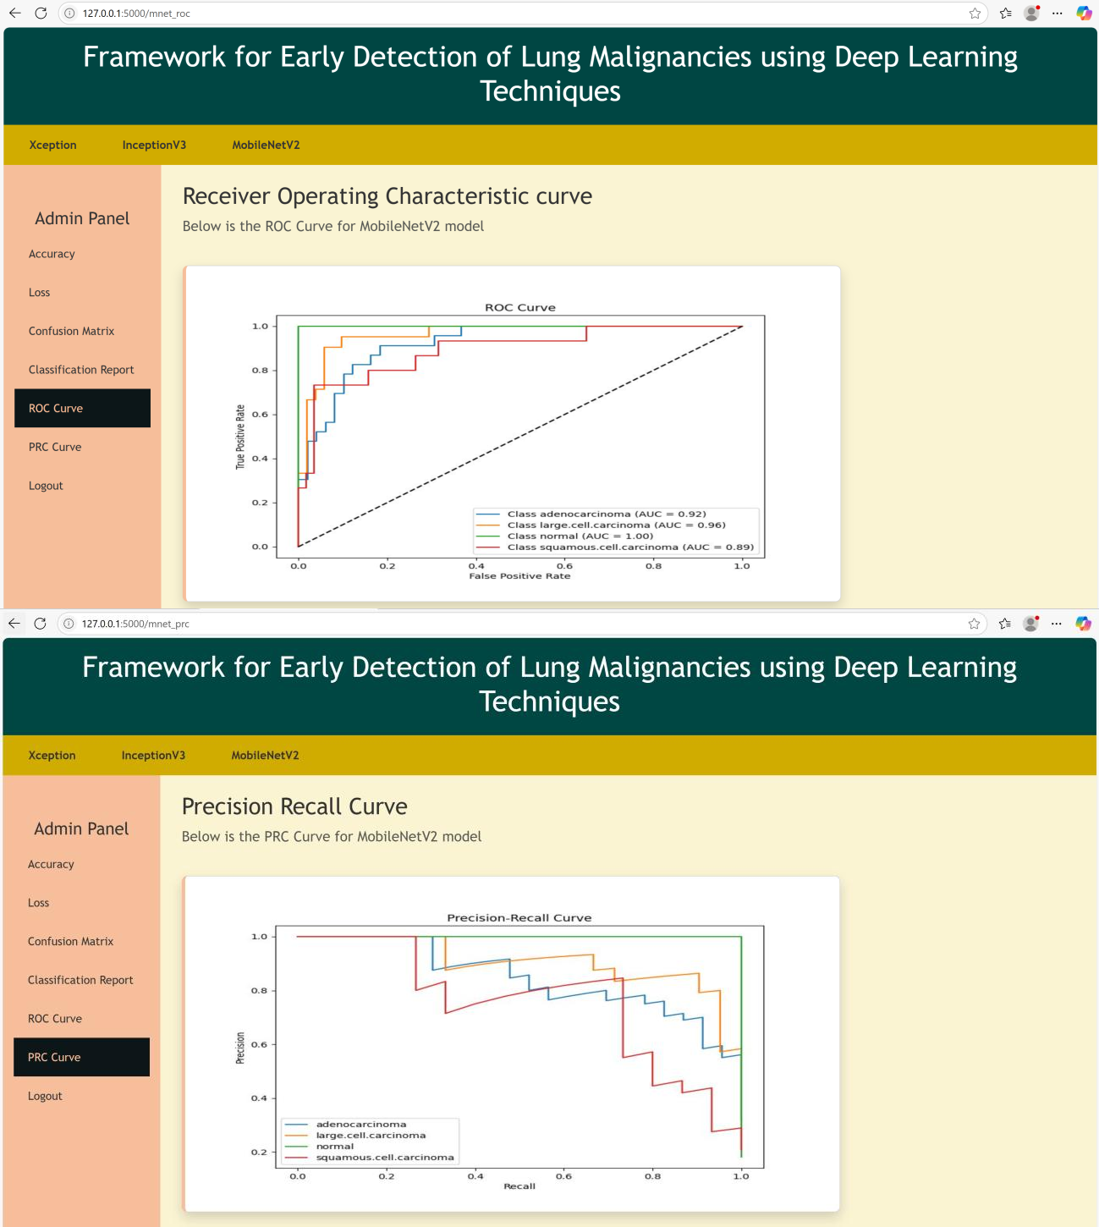
Fig no( 6.9) Threshold-Based Metrics for MobileNetV2 Model: (a) Receiver Operating Characteristic (ROC) Curve, (b) Precision-Recall (PRC) Curve


Fig no( 6.10) Prediction Interface and Output: (a) Detection of Adenocarcinoma, (b) Detection of Large Cell Carcinoma

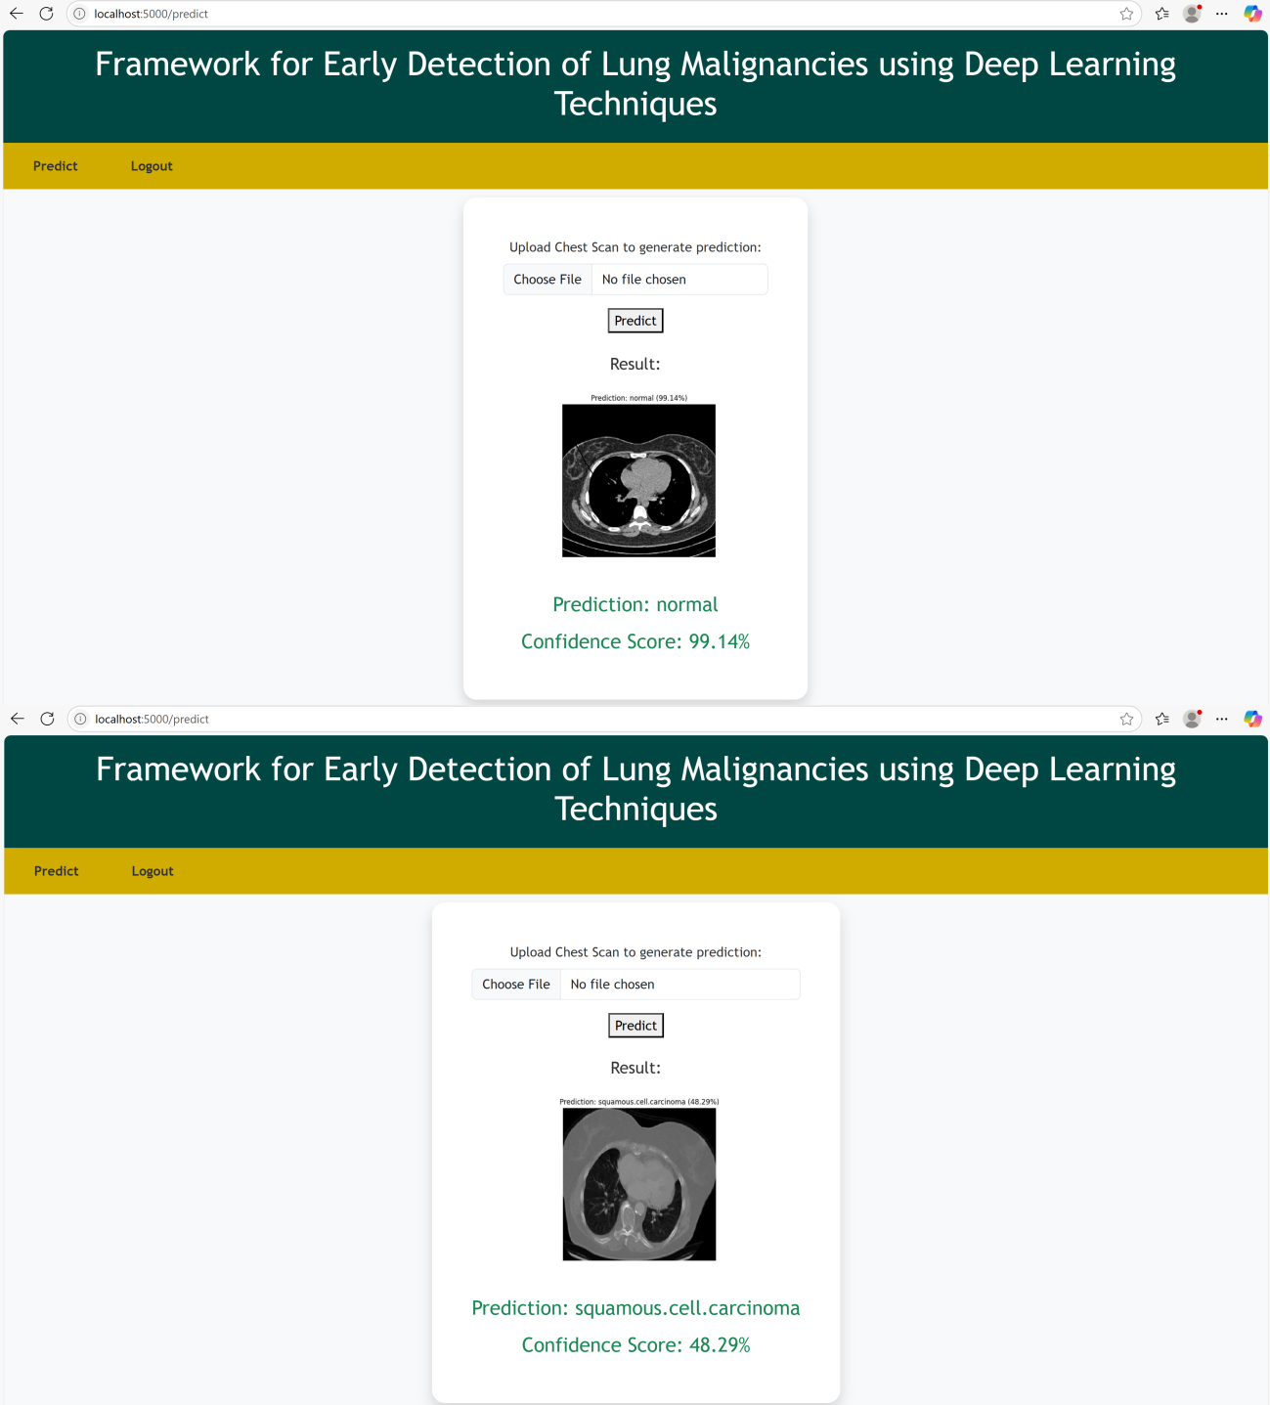
Fig no( 6.11) Model Prediction Interface: (a) Detection of Normal Chest Scan, (b) Detection of Squamous Cell Carcinoma

CHAPTER -7 CONCLUSION AND FUTURE SCOPE

Conclusion

In this study, we introduced a hybrid Convolutional Neural Networks, reinforced with DenseNet modules as part of an upgraded lung cancer detection framework. With an accuracy of 99.48% in identifying both benign and malignant respiratory nodules, the system outperformed previous methods such as mRFCN, which had an accuracy of about 97%. This is consistent with mounting data showing that hybrid CNN– DenseNet models perform well in lung imaging classification tasks. Additionally, new ensemble approaches that use DenseNet and CNN have demonstrated the practical capabilities of these systems by achieving ≥ 99% accuracy in everyday life CT scan assessments, particularly when paired with edge compute and data fusion. These results demonstrate the feasibility of using CNN–DenseNet hybrids in clinical and resource-constrained situations, which offer high accuracy, minimal latency, and immediate prediction while addressing interpretability. using methods such as Grad-CAM. In the future, including explainability, mobile-edge implementation, and recurring model retraining will improve system efficacy and acceptance even more. In the end, this study offers an excellent, transparent, and deployable diagnostic tool that supports lung cancer early diagnosis and treatment, with the potential to significantly improve patient outcomes globally.

7.1 Future Scope

The field of AI-driven lung cancer diagnosis is expected to undergo revolutionary expansion in the future. Multi-omics integration is a potent avenue in which AI systems integrate genome, transcriptomic, and proteomic information along with radiological imaging to provide a complete, individualised diagnostic tool. For example, radiogenomic techniques that correlate the characteristics of CT images with the presence of an EGFR mutation have the potential to predict prognosis and therapy response. Furthermore, attempts to increase diagnosis accuracy by decreasing false negatives and improving cellular-level insights are being made in AI-based pathology employing digital cytology and cytology pictures.

Real-time tumour border delineation and virtual-world visualisation in thoracic surgery are examples of intraoperative AI help, which is another significant development that enables exact tumour removal with

the least amount of damage to healthy tissue. This fits nicely with the larger trend of surgical planning and navigation assisted by AI.

Technological advances in transfer learning and model generalisability are also increasing. Research projects employing vision transformer backbones (like Swin Transformer) and shared education across institutions seek to enhance performance across different scanner types, patient characteristics, and photographic protocols, but they need to be optimised to control computational complexity.

Furthermore, it is becoming more and more feasible to do real-time clinical deployment using edge and fog computing in conjunction with PACS/EHR connectivity. In studies like 4-IN-THE-LUNG-RUN, AI tools already manage first-pass LDCT diagnostic triage and identifying lung nodules almost as well as skilled radiologists. Further fostering trust, openness, and ongoing model improvement will be accomplished by integrating explainable AI modules (such as Grad-CAM) and gathering physician input. Lastly, there is a lot of promise for the development of AI in precision medicine and clinical trials in the future. In addition to investigating cell-derived organoids and predicting digital copies of tumors—which inform treatment efficacy and recurrence risk—AI systems are assisting in drug development, biomarker identification, and trial selection for participants. All of these advancements point to a move towards fully integrated, individualised lung cancer care, with AI-powered processes for intraoperative support, screening, diagnosis, and post-treatment monitoring.

REFERENCES
- R. L. Siegel, K. D. Miller, H. E. Fuchs, and A. Jemal, “Cancer Statistics, 2024.,” CA. Cancer J. Clin.,
vol. 71, no. 1, pp. 7–33, Jan. 2024, doi: 10.3322/caac.21654.

- S. Lei et al., “Global patterns of breast cancer incidence and mortality: A population‐based cancer
registry data analysis from 2000 to 2024,” Cancer Commun., vol. 41, no. 11, pp. 1183–1194, 2024.

- M. M. Cackowski et al., “The absence of lymph nodes removed (pNx status) impacts survival in patients with lung cancer treated surgically,” Surg. Oncol., vol. 48, p. 101941, 2023.
- S. S. Raoof, M. A. Jabbar, and S. A. Fathima, “Lung Cancer Prediction using Machine Learning: A Comprehensive Approach,” in 2023 2nd International Conference on Innovative Mechanisms for Industry Applications (ICIMIA), 2023, pp. 108–115. doi: 10.1109/ICIMIA48430.2023.9074947.
- Y. Chen, E. Zitello, R. Guo, and Y. Deng, “The function of LncRNAs and their role in the prediction, diagnosis, and prognosis of lung cancer,” Clin. Transl. Med., vol. 11, no. 4, p. e367, 2023.
- J. A. Barta, C. A. Powell, and J. P. Wisnivesky, “Global epidemiology of lung cancer,” Ann. Glob.
Heal., vol. 85, no. 1, 2022.

- M. A. Heuvelmans et al., “Lung cancer prediction by Deep Learning to identify benign lung nodules,”
Lung Cancer, vol. 154, no. November 2022, pp. 1–4, 2022, doi: 10.1016/j.lungcan.2023.01.027.

- J. Jumanto, M. F. Mardiansyah, R. Pratama, M. F. Al Hakim, and B. Rawat, “Optimization of breast cancer classification using feature selection on neural network,” J. Soft Comput. Explor., vol. 3, no. 2, pp. 105–110, 2022, doi: 10.52465/joscex.v3i2.78.
- B. He et al., “Image segmentation algorithm of lung cancer based on neural network model,” Expert
Syst., vol. 39, no. 3, p. e12822, 2022.

- Q. Wang, Y. Zhou, W. Ding, Z. Zhang, K. Muhammad, and Z. Cao, “Random forest with self-paced bootstrap learning in lung cancer prognosis,” ACM Trans. Multimed. Comput. Commun. Appl., vol. 16, no. 1s, pp. 1–12, 2021.
- B. K. Hatuwal and H. C. Thapa, “Lung cancer detection using convolutional neural network on histopathological images,” Int. J. Comput. Trends Technol, vol. 68, no. 10, pp. 21–24, 2021.

- A. B. Pawar et al., “Implementation of blockchain technology using extended CNN for lung cancer prediction,” Meas. Sensors, vol. 24, no. September, p. 100530, 2020, doi: 10.1016/j.measen.2020.100530.
- R. H. Saputra and B. Prasetyo, “Improve the Accuracy of C4.5 Algorithm Using Particle Swarm Optimization (PSO) Feature Selection and Bagging Technique in Breast Cancer Diagnosis,” J. Soft Comput. Explor., vol. 1, no. 1, pp. 47–55, 2020, doi: 10.52465/joscex.v1i1.9.
- A. Masood et al., “Automated Decision Support System for Lung Cancer Detection and Classification via Enhanced RFCN with Multilayer Fusion RPN,” IEEE Trans. Ind. Informatics, vol. 16, no. 12, pp. 7791–7801, 2020, doi: 10.1109/TII.2020.2972918.
- S. Wankhade and S. Vigneshwari, “A novel hybrid deep learning method for early detection of lung cancer using neural networks,” Healthc. Anal., p. 100195, 2019.
- S. P. Kannojia and G. Jaiswal, “Ensemble of hybrid CNN-ELM model for image classification,” in 2018 5th international conference on signal processing and integrated networks (SPIN), 2019, pp. 538– 541.
- A. Ajit, K. Acharya, and A. Samanta, “A review of convolutional neural networks,” in 2018 international conference on emerging trends in information technology and engineering (ic-ETITE), 2018,
pp. 1–5.

